UNIVERSITY OF ILLINOIS
Urbana-Champaign • Chicago • Springfield

The Board of Trustees
352 Henry Administration Building, MC-350
506 South Wright Street
Urbana, IL 61801

NOTICE

August 17, 2020

A meeting of the Shield T3 LLC Board of Managers will be held Wednesday, August 19, 2020, beginning at 11 a.m. (A copy of the schedule is attached.)

Per Governor Pritzker’s Executive Order 2020-48 and 5 ILCS 120/7(e), this committee will meet via teleconference, available at: (312) 626-6799, meeting ID 993-8482-2902, password: 912509

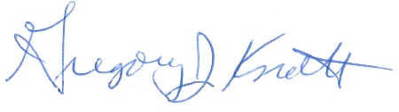
Gregory J. Knott
Secretary of the Board of Trustees

c. Members of the Board of Trustees
President Killeen
Mr. McKeever
University Officers
Members of the Press
Shield T3, LLC

Meeting of the Board of Managers

August 19, 2020
11:00 am – 1:00 pm
Online Meeting

Telephone: +1 312 626 6799
Meeting ID 993-8482-2902
Password: 912509

Open Session Agenda

- Call to Order
- Opening Remarks
- Action Item: Select Chair of the Board of Managers
- Discussion of Corporate Formation and Governing Documents
- Action Item: Elect Other Officers of BOM
  - Secretary of the Board of Managers
  - Treasurer
- Action Item: Approve Governance Documents
  - Articles of Organization
  - Operating Agreement
  - Services and Management Agreement
- Review of University Related Organization Regulations and Fiduciary Duties
- Executive Session
- Return to Open Session
- New Business
- Adjourn

Next Planned Meeting: To be determined

