UNIVERSITY OF ILLINOIS
Urbana-Champaign • Chicago • Springfield

The Board of Trustees
352 Henry Administration Building, MC-350
506 South Wright Street
Urbana, IL 61801
May 14, 2026
NOTICE

On call of the Chair, a meeting of the Academic and Student Affairs Committee of the Board of Trustees of the University of Illinois will be held on Wednesday, May 20, 2026, beginning at 3:15 p.m., in the I Hotel and Conference Center, Illinois Ballroom, 1900 South First Street, Champaign, Illinois. (A copy of the schedule/agenda is attached.)

The meeting will also be webcast live at the following address: https://www.uis.edu/uislive.

The Board of Trustees meetings are open to the public, pursuant to Illinois state law and the Board’s own procedures. Attendees will not be permitted to knowingly interfere with or impede, through disruptions or other means, the Board’s performance of its institutional duties. Individuals who disrupt the meeting will be asked to leave. If the disruption continues following due notice to depart the meeting space, individuals will be removed from the premises. Individuals who disrupt the Board’s performance of its institutional duties or refuse to leave the meeting may be in violation of state laws, including but not limited to the Illinois Interference with a Public Institution of Education Act.

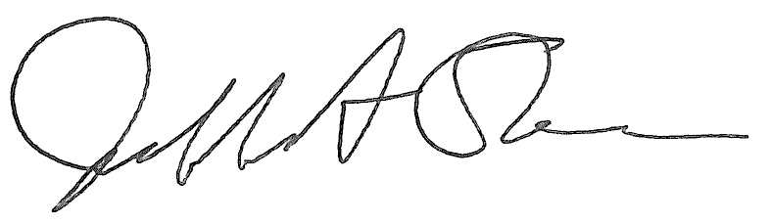
Jeffrey A. Stein Secretary of the Board of Trustees

c: Members of the Board of Trustees
President Killeen
Mr. Engle
University Officers
Members of the Press

Meeting of the Academic and Student Affairs Committee
of the Board of Trustees of the University of Illinois

University of Illinois Urbana-Champaign
I Hotel and Conference Center, Illinois Ballroom
1900 South First Street, Champaign, Illinois
The Academic and Student Affairs Committee Meeting will be webcast live at the following address:
https://www.uis.edu/uislive
Please be advised that the times for various parts of the meeting are estimates and that the order of business may be adjusted as the meeting progresses.

Wednesday, May 20, 2026
3:15 p.m.* Meeting of the Committee Convenes
- Roll Call
- Opening Remarks by the Chair of the Committee
- Action Item- Approval of Minutes of Meeting of March 18, 2026

3:20 p.m. Review Recommended Board Items for May 21, 2026, Board Meeting
- Appointments to the Faculty, Administrative/Professional Staff, and Intercollegiate Athletic Staff
- Establish the Department of Internal Medicine, Carle Illinois College of Medicine, Urbana
- Establish the Department of Obstetrics and Gynecology, Carle Illinois College of Medicine, Urbana
- Establish the Department of Psychiatry, Carle Illinois College of Medicine, Urbana
- Establish the Department of Family Medicine, Carle Illinois College of Medicine, Urbana
- Establish the Department of Agricultural Leadership, Education, and Communications, College of Agricultural, Consumer and Environmental Sciences, Urbana
- Establish the Bachelor of Science in Consumer Economics and Finance, College of Agricultural, Consumer and Environmental Sciences, Urbana
- Establish the Bachelor of Science in Environmental and Resource Economics and Policy, College of Agricultural, Consumer and Environmental Sciences, Urbana
- Establish the Bachelor of Science in Financial Planning, College of Agricultural, Consumer and Environmental Sciences, Urbana
- Establish the Bachelor of Science in Food and Agribusiness Management, College of Agricultural, Consumer and Environmental Sciences, Urbana
- Establish the Bachelor of Science in Public Policy and Law, College of Agricultural, Consumer and Environmental Sciences, Urbana
- Establish the Bachelor of Science in Liberal Arts and Sciences in Economics + Data Science, College of Liberal Arts and Sciences, Urbana
- Establish the Bachelor of Science in Liberal Arts and Sciences in History + Data Science, College of Liberal Arts and Sciences, Urbana
- Establish the Bachelor of Science in Liberal Arts and Sciences in Linguistics + Data Science, College of Liberal Arts and Sciences, Urbana
- Establish the Bachelor of Science in Liberal Arts and Sciences in Mathematics + Data Science, College of Liberal Arts and Sciences, Urbana
- Appoint Faculty Fellows to the Institute for the Humanities, College of Liberal Arts and Sciences, Chicago
- Establish the Bachelor of Science in Liberal Arts and Sciences, Major in Integrated Data Analytics, College of Liberal Arts and Sciences, Chicago
- Rename the Bachelor of Science in Rehabilitation Sciences, College of Applied Health Sciences, Chicago
- Appoint Vice Chancellor for Enrollment and Retention Management, Springfield
- Establish the Bachelor of Science in Artificial Intelligence, College of Health, Science, and Technology, Springfield

4:15 p.m. Presentation
- Updates and Impact of the Carle Illinois College of Medicine

4:25 p.m. Old Business

New Business
  - Next Meeting- July 15, 2026, 3:15 p.m., I Hotel and Conference Center, Illinois Ballroom, 1900 South First Street, Champaign

4:30 p.m. Meeting of the Committee Adjourns When Business is Completed

Per hotel management, the I Hotel and Conference Center does not permit signs inside the facility. All bags will be subject to inspection.

