UNIVERSITY OF ILLINOIS
Urbana-Champaign • Chicago • Springfield

The Board of Trustees
352 Henry Administration Building, MC-350
506 South Wright Street
Urbana, IL 61801
November 6, 2026

NOTICE

On call of the Chair, a meeting of the Audit, Budget, Finance, and Facilities Committee of the Board of Trustees of the University of Illinois will be held on Wednesday, November 11, 2026, beginning at 1:45 p.m., in the Isadore and Sadie Dorin Forum, Rooms D, E, and F, 725 West Roosevelt Road, Chicago, Illinois. (A copy of the schedule/agenda is attached.)

The meeting will also be webcast live at the following address:
https://www.uis.edu/uislive.

The Board of Trustees meetings are open to the public, pursuant to Illinois state law and the Board’s own procedures. Attendees will not be permitted to knowingly interfere with or impede, through disruptions or other means, the Board’s performance of its institutional duties. Individuals who disrupt the meeting will be asked to leave. If the disruption continues following due notice to depart the meeting space, individuals will be removed from the premises. Individuals who disrupt the Board’s performance of its institutional duties or refuse to leave the meeting may be in violation of state laws, including but not limited to the Illinois Interference with a Public Institution of Education Act.

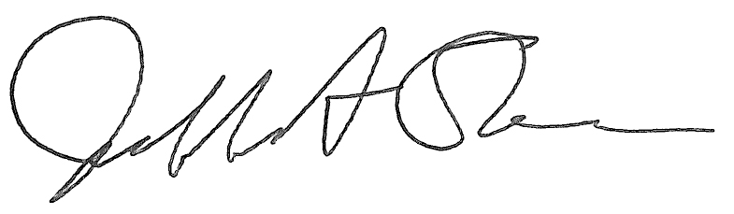
Jeffrey A. Stein Secretary of the Board of Trustees

c: Members of the Board of Trustees
President Killeen
Mr. Engle
University Officers
Members of the Press
Meeting of the Audit, Budget, Finance, and Facilities Committee
of the Board of Trustees of the University of Illinois

University of Illinois Chicago
Isadore and Sadie Dorin Forum, Rooms D, E, and F
725 West Roosevelt Road, Chicago, Illinois

The Audit, Budget, Finance, and Facilities Committee Meeting will be webcast live at the following address:
https://www.uis.edu/uislive

Please be advised that the times for various parts of the meeting are estimates and that the order of business may be adjusted as the meeting progresses.

Wednesday, November 11, 2026
1:45 p.m.* Meeting of the Committee Convenes
- Roll Call
- Opening Remarks by the Chair of the Committee
- Action Item- Approval of Minutes of Meeting of September 16, 2026

1:50 p.m. Review Recommended Board Items for November 12, 2026, Board Meeting
    - Approve Request for Operating and Capital Appropriations, Fiscal Year 2028
    - Approve Removal of Van Doren and Taft Residence Halls from Auxiliary Facilities System, Urbana
    - Approve Project Design for Ikenberry Residence Hall 4 and Demo 0091, 0092, Urbana
      - Ikenberry Residence Hall 4 and DEMO 0091, 0092
    - Approve Project and Professional Services Consultant Contract for IQUIST Materials Research Laboratory Renovation, Urbana
    - Name Small Animal Clinic Oncology Center Addition, Veterinary Teaching Hospital, Urbana
    - Approve Change to Construction Contract for Leah J. Wightman Round Barns and Manager’s House Exterior Renovation Addition, Urbana
    - Approve Project and Design, UI Health Clinical Decision Unit and Southeast Quadrant Hospital Access Expansion, Chicago
      - UI Health Clinical Decision Unit and Southeast Quadrant Hospital Access Expansion
    - Approve Project Budget for New Chiller for Drug Discovery and Cancer Research Pavilion, Chicago
    - Delegate Authority to the Comptroller to Approve Lease of Space for the University of Illinois College of Medicine Peoria at 4600 N. Brandywine Dr., Peoria, IL, Chicago
    - Purchase Recommendations

2:50 p.m. Presentations
- Chief Financial Officer Summary for Fiscal Year 2026
- Summary of Internal Audit Activity Through First Quarter Ended September 30, 2026
- University of Illinois Foundation Investment Update

3:20 p.m. Old Business

New Business
  - Next Meeting- January 20, 2027, 1:45 p.m., Isadore and Sadie Dorin Forum, Rooms D, E, and F, 725 West Roosevelt Road, Chicago

3:25 p.m. Executive Session

3:30 p.m. Meeting Reconvenes
- Action Item- Disclose Certain Minutes of Executive Session Pursuant to the Open Meetings Act

3:35 p.m. Meeting of the Committee Adjourns When Business is Complete

The UIC Dorin Forum does not permit graphic boards or posters inside the facility. All bags will be subject to inspection.

