UNIVERSITY OF ILLINOIS
Urbana-Champaign • Chicago • Springfield

The Board of Trustees
352 Henry Administration Building, MC-350
506 South Wright Street
Urbana, IL 61801
November 6, 2025

NOTICE

On call of the Chair, a meeting of the Audit, Budget, Finance, and Facilities Committee of the Board of Trustees of the University of Illinois will be held on Wednesday, November 12, 2025, beginning at 2:40 p.m., in the Isadore and Sadie Dorin Forum, Rooms D, E, and F, 725 West Roosevelt Road, Chicago, Illinois. (A copy of the schedule/agenda is attached.)

The meeting will also be webcast live at the following address:
https://www.uis.edu/uislive.

The Board of Trustees meetings are open to the public, pursuant to Illinois state law and the Board’s own procedures. Attendees will not be permitted to knowingly interfere with or impede, through disruptions or other means, the Board’s performance of its institutional duties. Individuals who disrupt the meeting will be asked to leave. If the disruption continues following due notice to depart the meeting space, individuals will be removed from the premises. Individuals who disrupt the Board’s performance of its institutional duties or refuse to leave the meeting may be in violation of state laws, including but not limited to the Illinois Interference with a Public Institution of Education Act.

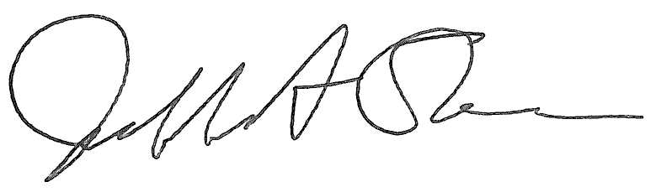
Jeffrey A. Stein Secretary of the Board of Trustees

c: Members of the Board of Trustees
President Killeen
Mr. Engle
University Officers
Members of the Press
Meeting of the Audit, Budget, Finance, and Facilities Committee
of the Board of Trustees of the University of Illinois

University of Illinois Chicago
Isadore and Sadie Dorin Forum, Rooms D, E, and F
725 West Roosevelt Road, Chicago, Illinois

The Audit, Budget, Finance, and Facilities Committee Meeting will be webcast live at the following address:
https://www.uis.edu/uislive

Please be advised that the times for various parts of the meeting are estimates and that the order of business may be adjusted as the meeting progresses.

Wednesday, November 12, 2025
2:40 p.m.* Meeting of the Committee Convenes
- Roll Call
- Opening Remarks by the Chair of the Committee
- Action Item- Approval of Minutes of Meeting of September 17, 2025

2:45 p.m. Review Recommended Board Items for November 13, 2025, Board Meeting
    - Approve Request for Operating and Capital Appropriations, Fiscal Year 2027
    - Delegate Authority to the Comptroller to Initiate a Public-Private Partnership Pre-Development Process and to Enter into Related Agreements to Construct the National Quantum Facility and Quantum Works, Urbana
    - Approve Project, Thomas M. Siebel School for Computer Science Addition, Urbana (Capital Development Board Project)
    - Approve Hope Village Community Collaboration Initiative, Urbana
    - Approve Project Budget and Employ Architect/Engineer Agricultural Engineering Sciences Building Roof Replacement and Masonry Repair, Urbana (Capital Development Board Project)
    - Rename Motorcycle Safety Building, Urbana
    - Name State Farm Center East Circle Drive, Urbana
    - Purchase Recommendations

3:15 p.m. Presentations
- FY25 Financial Summary
- Summary of Internal Audit Activity Through First Quarter Ended September 30, 2025

3:40 p.m. Old Business

New Business
  - Next Meeting- January 14, 2026, 2:15 p.m., Isadore and Sadie Dorin Forum, Rooms D, E, and F, 725 West Roosevelt Road, Chicago

3:45 p.m. Executive Session

3:50 p.m. Meeting of the Committee Reconvenes
  - Action Item- Disclose Certain Minutes of Executive Session Pursuant to the Open Meetings Act

3:55 p.m. Meeting of the Committee Adjourns When Business is Complete

The UIC Dorin Forum does not permit graphic boards or posters inside the facility. All bags will be subject to inspection.

