UNIVERSITY OF ILLINOIS
Urbana-Champaign • Chicago • Springfield

The Board of Trustees
352 Henry Administration Building, MC-350
506 South Wright Street
Urbana, IL 61801
November 6, 2025
NOTICE

On call of the Chair, a meeting of the Academic and Student Affairs Committee of the Board of Trustees of the University of Illinois will be held on Wednesday, November 12, 2025, beginning at 4:00 p.m., in the Isadore and Sadie Dorin Forum, Rooms D, E, and F, 725 West Roosevelt Road, Chicago, Illinois. (A copy of the schedule/agenda is attached.)

The meeting will also be webcast live at the following address: https://www.uis.edu/uislive.

The Board of Trustees meetings are open to the public, pursuant to Illinois state law and the Board’s own procedures. Attendees will not be permitted to knowingly interfere with or impede, through disruptions or other means, the Board’s performance of its institutional duties. Individuals who disrupt the meeting will be asked to leave. If the disruption continues following due notice to depart the meeting space, individuals will be removed from the premises. Individuals who disrupt the Board’s performance of its institutional duties or refuse to leave the meeting may be in violation of state laws, including but not limited to the Illinois Interference with a Public Institution of Education Act.

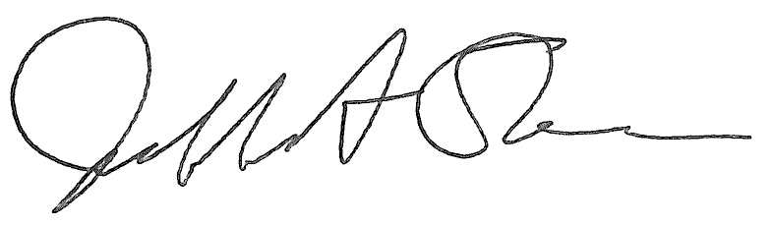
Jeffrey A. Stein Secretary of the Board of Trustees

c: Members of the Board of Trustees
President Killeen
Mr. Engle
University Officers
Members of the Press

Meeting of the Academic and Student Affairs Committee
of the Board of Trustees of the University of Illinois

University of Illinois Chicago
Isadore and Sadie Dorin Forum, Rooms D, E, and F
725 West Roosevelt Road, Chicago, Illinois
The Academic and Student Affairs Committee Meeting will be webcast live at the following address:
https://www.uis.edu/uislive
Please be advised that the times for various parts of the meeting are estimates and that the order of business may be adjusted as the meeting progresses.

Wednesday, November 12, 2025
4:00 p.m.* Meeting of the Committee Convenes
- Roll Call
- Opening Remarks by the Chair of the Committee
- Action Item- Approval of Minutes of Meeting of September 17, 2025

4:05 p.m. Review Recommended Board Items for November 13, 2025, Board Meeting
- Appointments to the Faculty, Administrative/Professional Staff, and Intercollegiate Athletic Staff
- Approve Interim University of Illinois System Policy on Integrity in Research and Scholarly Activities
- Appoint Vice Chancellor for Student Affairs, Chicago
- Establish the Social and Behavioral Sciences Institute as a Permanent Institute, Office of the Vice Chancellor for Research and Innovation, Urbana
- Establish the Bachelor of Arts in Sports Media, College of Media, Urbana
- Appoint Interim G. Stephen Irwin Dean, College of Medicine, Chicago
4:20 p.m. Presentation
- The University of Illinois Residential Experience – A Perspective from All Three Universities

4:40 p.m. Old Business

New Business
  - Next Meeting- January 14, 2026, 3:30 p.m., Isadore and Sadie Dorin Forum, Rooms D, E, and F, 725 West Roosevelt Road, Chicago

4:45 p.m. Meeting of the Committee Adjourns When Business is Completed

The UIC Dorin Forum does not permit graphic boards or posters inside the facility. All bags will be subject to inspection.

