UNIVERSITY OF ILLINOIS
Urbana-Champaign • Chicago • Springfield

The Board of Trustees
352 Henry Administration Building, MC-350
506 South Wright Street
Urbana, IL 61801

NOTICE

March 29, 2021

On call of the chair, a meeting of the Executive Committee of the Board of Trustees of the University of Illinois will be held Thursday, April 1, 2021, beginning at 7:00 a.m. (A copy of the schedule is attached.)

Per Governor Pritzker’s Executive Order 2021-05 and 5 ILCS 120/7(e), this committee will meet via teleconference, available at: http://www.uis.edu/technology/uislive.html.

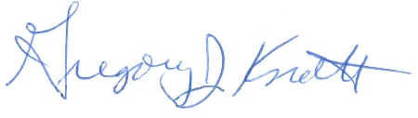
Gregory J. Knott
Secretary of the Board of Trustees

c. Members of the Board of Trustees
President Killeen
Mr. McKeever
University Officers
Members of the Press
Meeting of the Executive Committee
of the Board of Trustees
University of Illinois

April 1, 2021

VIRTUAL MEETING ROOM

The Executive Committee of the Board of Trustees Meeting will be webcast live at the following address: http://www.uis.edu/technology/uislive.html

Please note that the starting times for various sessions, after the first session, are estimates. If a session ends earlier than expected, the next session scheduled may convene immediately. In addition, on some occasions the order of business may be adjusted as the meeting progresses to accommodate board members’ schedules, the length of sessions, breaks and other needs.

7:00 a.m. Meeting of the Executive Committee Convenes
- Roll Call
- Identification of University Officers and Others Present

7:02 a.m. Presentation of Item on Agenda
- Presentation of Regular Agenda
- Vote on Regular Agenda Item

7:20 a.m. Meeting of the Executive Committee Adjourns

REGULAR AGENDA

- Extend the Revision to the Policy Requiring Standardized Tests for Freshman Admission to Undergraduate Programs for Academic Years 2022-2023 and 2023-2024

