UNIVERSITY OF ILLINOIS
Urbana-Champaign • Chicago • Springfield

The Board of Trustees
352 Henry Administration Building, MC-350
506 South Wright Street
Urbana, IL 61801

NOTICE

August 13, 2024

On call of the chair, a meeting of the Executive Committee of the Board of Trustees of the University of Illinois will be held Thursday, August 15, 2024, beginning at 2:00 p.m., in the Isadore and Sadie Dorin Forum, Room H, 725 West Roosevelt Road, Chicago. (A copy of the schedule is attached.)

The Board of Trustees meetings are open to the public, pursuant to Illinois state law and the Board’s own procedures. Attendees will not be permitted to knowingly interfere with or impede, through disruptions or other means, the Board’s performance of its institutional duties. Individuals who disrupt the meeting will be asked to leave. If the disruption continues following due notice to depart the meeting space, individuals will be removed from the premises. Individuals who disrupt the Board’s performance of its institutional duties or refuse to leave the meeting may be in violation of state laws, including but not limited to the Illinois Interference with a Public Institution of Education Act.

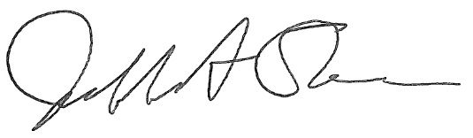

Jeffrey A. Stein
Secretary, Board of Trustees
c. Members of the Board of Trustees
President Killeen
Mr. McKeever
University Officers
Members of the Press
University of Illinois Board of Trustees Executive Committee

Meeting Schedule and Agenda List
Thursday, August 15, 2024

University of Illinois Chicago
Isadore and Sadie Dorin Forum, Room H
725 West Roosevelt Road, Chicago, Illinois

Please note that the starting times for various sessions, after the first session, are estimates. If a session ends earlier than expected, the next session scheduled may convene immediately. In addition, on some occasions the order of business may be adjusted as the meeting progresses to accommodate board members’ schedules, the length of sessions, breaks and other needs.

2:00 p.m. Meeting of the Executive Committee Convenes
- Roll Call
- Identification of University Officers and Others Present
- Public Comment

2:05 p.m. Presentation of Items on Agenda
- Presentation of Regular Agenda Items
- Roll Call Vote on Regular Agenda Items

2:30 p.m. Meeting of the Executive Committee Adjourns

Roll Call Agenda
- Approve Execution of University-Related Organization Governing Documents

- Appoint Board of Managers for Illinois Quantum and Microelectronics Park, LLC

The UIC Dorin Forum does not permit graphic boards or posters inside the facility. All bags will be subject to inspection.

