UNIVERSITY OF ILLINOIS

Urbana-Champaign • Chicago • Springfield

The Board of Trustees

352 Henry Administration Building, MC-350

506 South Wright Street

Urbana, IL 61801

**NOTICE**

### August 21, 2020

A meeting of the Shield T3 LLC Board of Managers Executive Committee will be held Tuesday, August 25, 2020, beginning at 8:30 a.m. (A copy of the schedule is attached.)

Per Governor Pritzker’s Executive Order 2020-48 and 5 ILCS 120/7(e), this committee will meet via teleconference, available at: (312) 626-6799, meeting ID 995-8732-0607, password: 222989

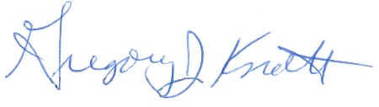

Gregory J. Knott

Secretary of the Board of Trustees

c. Members of the Board of Trustees  
President Killeen  
Mr. McKeever

University Officers  
Members of the Press

**Shield T3, LLC**

**Meeting of the Board of Managers Executive Committee**

**August 25, 2020**

**8:30 a.m.**

**Online Meeting**

**Telephone: +1 312 626 6799**

**Meeting ID 995-8732-0607**

**Password: 222989**

**Open Session Agenda**

1. Call to Order
2. Opening Remarks
3. Executive Session
4. Return to Open Session
5. Adjourn

**Next Planned Meeting: To be determined**