UNIVERSITY OF ILLINOIS
Urbana-Champaign • Chicago • Springfield

The Board of Trustees
352 Henry Administration Building, MC-350
506 South Wright Street
Urbana, IL 61801

NOTICE

November 30, 2022

On call of the chair, a meeting of the Ad Hoc Search Committee for the Secretary of the Board of Trustees and of the University will be held on Friday, December 2, 2022, beginning at 1 p.m. (A copy of the schedule/agenda is attached.)

For a portion of the meeting, the committee will meet in closed session to consider University employment or appointment-related matters.

Per Governor Pritzker’s November 10, 2022, Gubernatorial Disaster Proclamation and 5 ILCS 120/7(e), this meeting will be held via teleconference, available at: http://www.uis.edu/uislive.

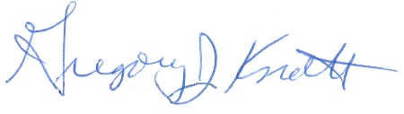
Gregory J. Knott
Secretary of the Board of Trustees

c. Members of the Board of Trustees
President Killeen
Mr. McKeever
University Officers
Members of the Press
Meeting of the Ad Hoc Search Committee
for the Secretary of the Board of Trustees and of the University
University of Illinois

Virtual Meeting

The committee meeting will be webcast live at the following address:
http://www.uis.edu/uislive

Please note that the starting times are estimates and the order of business may be adjusted as the meeting progresses.

Friday, December 2, 2022

1:00 p.m. Meeting of the search committee convenes
- Roll call
- Statement of committee’s charge
- Briefing on search procedures
- Review of affirmative action procedures for searches
- Opening remarks by the chair of the committee

1:10 p.m. Motion for Executive Session

The committee meets in executive session to consider University employment or appointment-related matters.

2:00 p.m. Meeting of the search committee adjourns

