UNIVERSITY OF ILLINOIS
Urbana-Champaign • Chicago • Springfield

The Board of Trustees
352 Henry Administration Building, MC-350
506 South Wright Street
Urbana, IL 61801

NOTICE

April 16, 2026

A meeting of the Illinois Quantum and Microelectronics Park, LLC Board of Managers will be held Tuesday, April 21, 2026, beginning at 10:00 a.m. (A copy of the schedule is attached.)

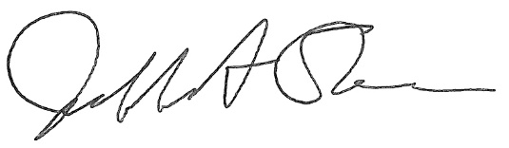

Jeffrey A. Stein
Secretary, Board of Trustees
c. Members of the Board of Managers
President Killeen
University Officers
Members of the Press
Illinois Quantum and Microelectronics Park, LLC

Board of Managers Meeting
April 21, 2026, 10:00 AM CST

Isadore and Sadie Dorin Forum, Rooms G, H & I
725 W. Roosevelt Rd, Chicago IL

10:00 am Convene Meeting of the IQMP Board of Managers
- Roll Call
- Welcoming Remarks from Wilbur Milhouse III, Chair
- Remarks from Timothy Killeen, President, UI System

10:05 am Director/CEO Report
Harley Johnson, IQMP Director and Chief Executive Officer

10:35 am Presentations
FY 2027 Operating Budget Preview (July 1, 2026 – June 30, 2027)
Lauren Wilson, Chief Operations Officer

10:50 am Public Comment

11:10 am Action Agenda and Voting
- Approve Minutes of February 17, 2026, Meeting of the Illinois Quantum and Microelectronics Park, LLC Board of Managers

11:15 am Old Business
New Business

11:20 am Executive Session
There may or may not be an executive session during this period depending on the business at hand.

11:40 am Open Session Resumes

11:40 pm Adjourn Meeting

