UNIVERSITY OF ILLINOIS
Urbana-Champaign • Chicago • Springfield

The Board of Trustees
352 Henry Administration Building, MC-350
506 South Wright Street
Urbana, IL 61801

NOTICE

April 17, 2025

A meeting of the Illinois Quantum and Microelectronics Park, LLC Board of Managers will be held Tuesday, April 22, 2025, beginning at 10:00 a.m. (A copy of the schedule is attached.)

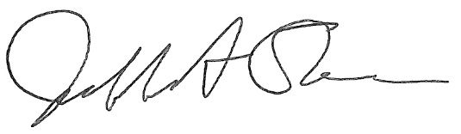

Jeffrey A. Stein
Secretary, Board of Trustees
c. Members of the Board of Managers
President Killeen
University Officers
Members of the Press

Illinois Quantum and Microelectronics Park, LLC

Board of Managers Meeting

April 22, 2025, 10:00 AM CST

Isadore and Sadie Dorin Forum, Rooms D&E
725 W. Roosevelt Rd, Chicago IL

10:00 am Convene Meeting of the IQMP Board of Managers

- Roll Call
- Welcoming Remarks from Wilbur C. Milhouse III, Chair
- Opening Remarks from Timothy Killeen, President, UI System
- Opening Remarks from Robert Jones, Vice President, UI System and Chancellor, University of Illinois Urbana-Champaign

10:15 am Director/CEO Report
Harley Johnson, IQMP director and Chief Executive Officer

11:00 am Site Development Update
Michael Ellch, Related Midwest senior vice president of development; Mary Person, Clayco senior vice president – public-private initiatives; and Sean Moran, Clayco Construction Sustainability Director

11:15 am Action Agenda and Voting

- Approve Minutes of February 25, 2025, Meeting of the Illinois Quantum and Microelectronics Park, LLC Board of Managers

- Approve IQMP Board of Managers Meeting Schedule
(August 2025 – June 2026)

- Approve Operating Budget FY 2026

11:20 am Public Comment

11:30 am Executive Session
There may or may not be an executive session during this period depending on the business at hand.

11:45 am Open Session Resumes

11:45 am Old Business
New Business

12:00 pm Adjourn Meeting

