UNIVERSITY OF ILLINOIS
Urbana-Champaign • Chicago • Springfield

The Board of Trustees
352 Henry Administration Building, MC-350
506 South Wright Street
Urbana, IL 61801

NOTICE

August 14, 2025

A meeting of the Illinois Quantum and Microelectronics Park, LLC Board of Managers will be held Tuesday, August 19, 2025, beginning at 10:00 a.m. (A copy of the schedule is attached.)

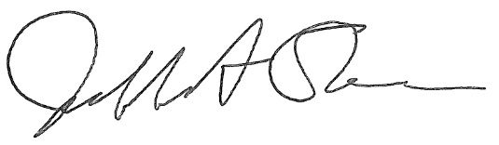

Jeffrey A. Stein
Secretary, Board of Trustees
c. Members of the Board of Managers
President Killeen
University Officers
Members of the Press

Illinois Quantum and Microelectronics Park, LLC

Board of Managers Meeting

August 19, 2025, 10:00 AM CST
University of Illinois Chicago, Student Center West
828 S. Wolcott Ave., Chicago

10:00 am Convene Meeting of the IQMP Board of Managers

- Roll Call
- Welcoming Remarks from Wilbur C. Milhouse III, Chair
- Remarks from UI System President Tim Killeen
- Remarks from UIUC Chancellor Charles Isbell

10:15 am Director/CEO Report
Harley Johnson, IQMP director and Chief Executive Officer

11:00 am Onramp Facility Update
Manas Mehandru, mHub Chief Operating Officer
Allison Winstel, mHub Chief of Staff

11:15 am IQMP Tenant Update
Pranav Gokhale, Infleqtion, Inc.Vice President and General Manager

11:30 am Public Comment

11:40 am Action Agenda and Voting
- Approve Minutes of April 22, 2025, Meeting of the Illinois Quantum and Microelectronics Park, LLC Board of Managers

11:45 am Executive Session
There may or may not be an executive session during this period depending on the business at hand.

11:50 am Open Session Resumes

11:55 am Old Business
New Business

12:00 pm Adjourn Meeting

Reports for Information Only

Executive Committee Meeting Report

