UNIVERSITY OF ILLINOIS
Urbana-Champaign • Chicago • Springfield

The Board of Trustees
352 Henry Administration Building, MC-350
506 South Wright Street
Urbana, IL 61801

NOTICE

December 11, 2025

A meeting of the Illinois Quantum and Microelectronics Park, LLC Board of Managers will be held Tuesday, December 16, 2025, beginning at 10:00 a.m. (A copy of the schedule is attached.)

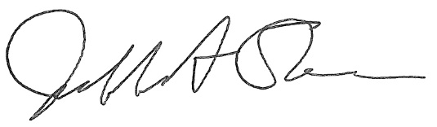

Jeffrey A. Stein
Secretary, Board of Trustees
c. Members of the Board of Managers
President Killeen
University Officers
Members of the Press

Illinois Quantum and Microelectronics Park, LLC

Board of Managers Meeting

December 16, 2025, 10:00 AM CST

Isadore and Sadie Dorin Forum, Rooms D, E&F
725 W. Roosevelt Rd, Chicago IL

10:00 am Convene Meeting of the IQMP Board of Managers
- Roll Call
- Welcoming Remarks from Wilbur Milhouse, Chair

10:10 am Director/CEO Report
Harley Johnson, IQMP director and Chief Executive Officer
- Emily Easton, IQMP Director of Education and Workforce Development
- Shaunna Sims-Davis, IQMP Community Advisor
- Sarah Crane, UI System Assistant Vice President Treasury Operations/Capital Markets

10:40 am Presentations
Advocate Health Update
- Michelle Blakely, President Advocate Trinity Hospital & Advocate South Side Healthcare Transformation
- Dia Nichols, President of Advocate Health Care
- Crystal Olsen, Area Vice President of Government Affairs for Advocate Health

Related Midwest – Site & Workforce Development Update
- Michael Ellch, Senior Vice President of Development

Psi Quantum Update
- Mark Brunner, Executive Vice President, Public Sector

11:35 am Public Comment

11:50 am Action Agenda and Voting
- Approve Minutes of October 14, 2025, Meeting of the Illinois Quantum and Microelectronics Park, LLC Board of Managers

- Approve FY27 Meeting Schedule

11:55 am Executive Session
There may or may not be an executive session during this period depending on the business at hand.

12:15 pm Open Session Resumes

12:15 pm Old Business
New Business

12:20 pm Adjourn Meeting

