UNIVERSITY OF ILLINOIS
Urbana-Champaign • Chicago • Springfield

The Board of Trustees
352 Henry Administration Building, MC-350
506 South Wright Street
Urbana, IL 61801

NOTICE

December 13, 2024

A meeting of the Illinois Quantum and Microelectronics Park, LLC Board of Managers will be held Tuesday, December 17, 2024, beginning at 2:00 p.m. (A copy of the schedule is attached.)

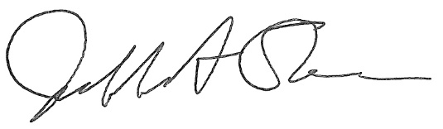

Jeffrey A. Stein
Secretary, Board of Trustees
c. Members of the Board of Managers
President Killeen
University Officers
Members of the Press

Illinois Quantum and Microelectronics Park, LLC

Board of Managers Meeting

December 17, 2024, 2:00 PM CST

Isadore and Sadie Dorin Forum, Rooms D&E
725 W. Roosevelt Rd, Chicago IL

2:00 pm Convene Meeting of the IQMP Board of Managers

- Roll Call
- Welcoming Remarks from Chair, Wilbur C. Milhouse III, Chair

2:10 pm Director/CEO Report
Harley Johnson, IQMP Director and Chief Executive Officer

3:00 pm Action Agenda

- Approve Minutes of October 24, 2024, Meeting of the Illinois Quantum and Microelectronics Park, LLC Board of Managers

- Approve Procedures Governing Appearances Before the Illinois Quantum and Microelectronics Park, LLC Board of Managers

3:10 pm Presentation

Illinois Quantum and Microelectronics Park, LLC Conflict of Interest Policy

3:20 pm Presentation

Directors and Officers Insurance

3:30 pm Presentation

IQMP Preliminary Operating Budget

3:50 pm Executive Session

4:35 pm Open Session Resumes

4:35 pm Public Comment

4:40 pm Old Business
New Business

4:45 pm Adjourn Meeting

