UNIVERSITY OF ILLINOIS
Urbana-Champaign • Chicago • Springfield

The Board of Trustees
352 Henry Administration Building, MC-350
506 South Wright Street
Urbana, IL 61801

NOTICE

February 20, 2025

A meeting of the Illinois Quantum and Microelectronics Park, LLC Board of Managers will be held Tuesday, February 25, 2025, beginning at 2:00 p.m. (A copy of the schedule is attached.)

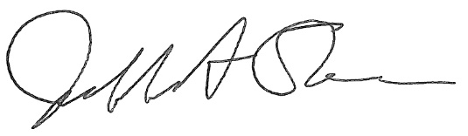

Jeffrey A. Stein
Secretary, Board of Trustees
c. Members of the Board of Managers
President Killeen
University Officers
Members of the Press

Illinois Quantum and Microelectronics Park, LLC

Board of Managers Meeting

February 25, 2025, 2:00 PM CST

University of Illinois Chicago Student Center West
828 S. Wolcott Ave., Chicago, IL
Thompson Rooms ABC

2:00 pm Convene Meeting of the IQMP Board of Managers

- Roll Call
- Welcoming Remarks from Wilbur C. Milhouse III, Chair
- Opening Remarks from Timothy Killeen, President UI System

2:10 pm Director/CEO Report
Harley Johnson, IQMP Director and Chief Executive Officer

3:00 pm Action Agenda and Voting

- Approve Minutes of December 17, 2024, Meeting of the Illinois Quantum and Microelectronics Park, LLC Board of Managers

- Approve IQMP Board of Managers Meeting Schedule (August 2025 – June 2026)

- Approve Conflict of Interest Policy

- Approve Operating Budget FY 2025

3:25 pm Presentations

3:25 pm Operating Budget for FY 2026 (July 1, 2025 – June 30, 2026)

3:50 pm Discovery Partners Institute Update

4:00 pm Executive Session
There may or may not be an executive session during this period depending on the business at hand.

4:20 pm Open Session Resumes

4:20 pm Public Comment

4:30 pm Old Business
New Business

4:35 pm Adjourn Meeting

