UNIVERSITY OF ILLINOIS
Urbana-Champaign • Chicago • Springfield

The Board of Trustees
352 Henry Administration Building, MC-350
506 South Wright Street
Urbana, IL 61801

NOTICE

June 30, 2025

A meeting of the Executive Committee of the Illinois Quantum and Microelectronics Park, LLC Board of Managers will be held Wednesday, July 2, 2025, beginning at 11:00 a.m. (A copy of the schedule is attached.)

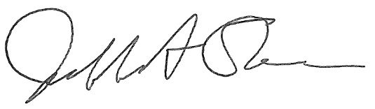

Jeffrey A. Stein
Secretary, Board of Trustees
c. Members of the Board of Managers
President Killeen
University Officers
Members of the Press

Illinois Quantum and Microelectronics Park, LLC

Executive Committee Meeting

July 2, 2025, 11:00 AM CST
Room 2006, 200 S. Wacker, Chicago, IL

11:00 am Convene Meeting of the IQMP Board Executive Committee

- Roll Call
- Identification of IQMP Officers and Others Present
- Public Comment

11:05 am Executive Session

11:20 am Presentation of Agenda Items and Voting

- Approve Resolution for Security Clearance Exclusion of Managers and Officers
- Approve Resolution for Creating the Facility Clearance (FCL) Executive Committee for Oversight and Management of the Illinois Quantum and Microelectronics Park, LLC FCL

11:30 am Meeting of the Executive Committee Adjourns

