UNIVERSITY OF ILLINOIS
Urbana-Champaign • Chicago • Springfield

The Board of Trustees
352 Henry Administration Building, MC-350
506 South Wright Street
Urbana, IL 61801

NOTICE - REVISED

June 13, 2025

A meeting of the Illinois Quantum and Microelectronics Park, LLC Board of Managers will be held Tuesday, June 17, 2025, beginning at 10:00 a.m. (A copy of the schedule is attached.)

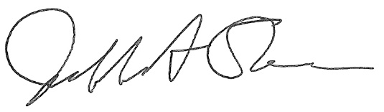

Jeffrey A. Stein
Secretary, Board of Trustees
c. Members of the Board of Managers
President Killeen
University Officers
Members of the Press

Illinois Quantum and Microelectronics Park, LLC

Board of Managers Meeting

June 17, 2025, 10:00 AM CST

Isadore and Sadie Dorin Forum, Rooms D, E&F
725 W. Roosevelt Rd, Chicago IL

10:00 am Convene Meeting of the IQMP Board of Managers

- Roll Call
- Welcoming Remarks from Wilbur C. Milhouse III, Chair

10:15 am Director/CEO Report
Harley Johnson, IQMP director and Chief Executive Officer

11:15 am Action Agenda and Voting

- Approve Minutes of April 22, 2025, Meeting of the Illinois Quantum and Microelectronics Park, LLC Board of Managers
- Approve Resolution for Security Clearance Exclusion of Managers and Officers ADDED
- Approve Resolution for Creating the Facility Clearance (FCL) Executive Committee for Oversight and Management of the Illinois Quantum and Microelectronics Park, LLC FCL ADDED

11:10 am Public Comment

11:20 am Executive Session
There may or may not be an executive session during this period depending on the business at hand.

11:35 am Open Session Resumes

11:40 am Old Business
New Business

11:45 am Adjourn Meeting

