UNIVERSITY OF ILLINOIS
Urbana-Champaign • Chicago • Springfield

The Board of Trustees
352 Henry Administration Building, MC-350
506 South Wright Street
Urbana, IL 61801

NOTICE

October 10, 2025

A meeting of the Illinois Quantum and Microelectronics Park, LLC Board of Managers will be held Tuesday, October 14, 2025, beginning at 10:00 a.m. (A copy of the schedule is attached.)

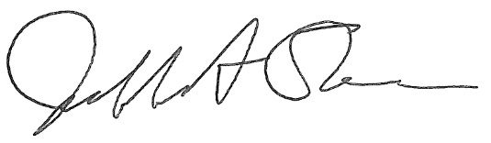

Jeffrey A. Stein
Secretary, Board of Trustees
c. Members of the Board of Managers
President Killeen
University Officers
Members of the Press

Illinois Quantum and Microelectronics Park, LLC

Board of Managers Meeting

October 14, 2025, 10:00 AM CST

Isadore and Sadie Dorin Forum, Rooms D, E&F
725 W. Roosevelt Rd, Chicago IL

10:00 am Convene Meeting of the IQMP Board of Managers

- Roll Call
- Welcoming Remarks from Rashid Bashir, Vice Chair

10:15 am Director/CEO Report
Harley Johnson, IQMP director and Chief Executive Officer

11:00 am Public Comment

11:10 am Action Agenda and Voting
- Approve Minutes of August 19, 2025, Meeting of the Illinois Quantum and Microelectronics Park, LLC Board of Managers

- Purchase Recommendation

11:15 am Executive Session
There may or may not be an executive session during this period depending on the business at hand.

11:25 am Open Session Resumes

11:30 am Old Business
New Business

11:35 am Adjourn Meeting

