UNIVERSITY OF ILLINOIS
Urbana-Champaign • Chicago • Springfield

The Board of Trustees
352 Henry Administration Building, MC-350
506 South Wright Street
Urbana, IL 61801

NOTICE

October 22, 2024

A meeting of the Illinois Quantum and Microelectronics Park, LLC Board of Managers will be held Thursday, October 24, 2024, beginning at 2:00 p.m. (A copy of the schedule is attached.)

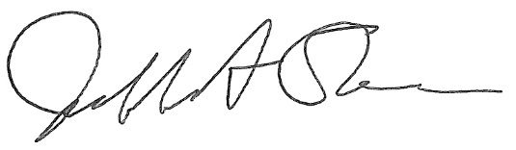

Jeffrey A. Stein
Secretary, Board of Trustees
c. Members of the Board of Managers
President Killeen
University Officers
Members of the Press

Illinois Quantum and Microelectronics Park, LLC

Board of Managers Meeting

October 24, 2024, 2:00 PM CST

Isadore and Sadie Dorin Forum, Rooms D&E
725 W. Roosevelt Rd, Chicago IL

2:00 pm Convene Meeting of the IQMP Board of Managers

- Roll Call
- Welcoming Remarks from Chair, Wilbur C. Milhouse III

2:05 pm Director/CEO Report
Harley Johnson, IQMP Director and Chief Executive Officer

2:35 pm Action Agenda

- Approve Minutes of September 25, 2024, Meeting of the Illinois Quantum and Microelectronics Park, LLC Board of Managers

- Approve Operating Agreement of the Illinois Quantum and Microelectronics Park, LLC

- Approve Services and Management Agreement of the Illinois Quantum and Microelectronics Park, LLC

- Approve Delegation of Signature Authority

2:55 pm Election of Executive Committee Representative and IQMP Board of Managers Vice Chair

3:00 pm Presentations
- Michael Ellch, Senior Vice President of Development, Related Midwest
- Josh Richman, Senior Vice President of Corporate Development, Psi Quantum

3:30 pm Executive Session

4:30 pm Open Session Resumes

Action Agenda, Continued

- Approve Agreements for Supply of Electric Power to Illinois Quantum and Microelectronics Park

- Approve Agreements for Supply of Cryoplant Systems to Illinois Quantum and Microelectronics Park

4:40 pm Public Comment

4:50 pm Old Business
New Business

4:55 pm Adjourn Meeting

