UNIVERSITY OF ILLINOIS
Urbana-Champaign • Chicago • Springfield

The Board of Trustees
352 Henry Administration Building, MC-350
506 South Wright Street
Urbana, IL 61801

NOTICE

October 7, 2025

A meeting of the Executive Committee of the Illinois Quantum and Microelectronics Park, LLC Board of Managers will be held Thursday, October 9, 2025, beginning at 3:00 p.m. (A copy of the schedule is attached.)

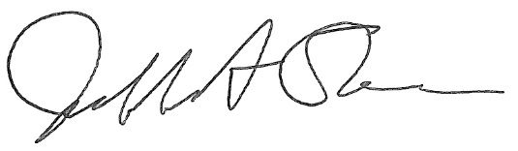

Jeffrey A. Stein
Secretary, Board of Trustees
c. Members of the Board of Managers
President Killeen
University Officers
Members of the Press

Illinois Quantum and Microelectronics Park, LLC

Executive Committee Meeting

October 9, 2025, 3:00 PM CST
Room 2017, 200 S. Wacker, Chicago, IL

3:00 pm Convene Meeting of the IQMP Board Executive Committee

- Roll Call
- Identification of IQMP Officers and Others Present
- Public Comment

3:05 pm Executive Session

3:55 pm Old Business
New Business

4:00 pm Meeting of the Executive Committee Adjourns

