UNIVERSITY OF ILLINOIS
Urbana-Champaign • Chicago • Springfield

The Board of Trustees
352 Henry Administration Building, MC-350
506 South Wright Street
Urbana, IL 61801

NOTICE

September 23, 2024

A meeting of the Illinois Quantum and Microelectronics Park, LLC Board of Managers will be held Wednesday, September 25, 2024, beginning at 2:30 p.m. (A copy of the schedule is attached.)

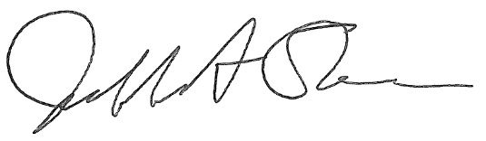

Jeffrey A. Stein
Secretary, Board of Trustees
c. Members of the Board of Managers
President Killeen
University Officers
Members of the Press
Illinois Quantum and Microelectronics Park, LLC

Board of Managers Meeting

September 25, 2024, 2:30 PM CST

Isadore and Sadie Dorin Forum, Room H
725 W. Roosevelt Rd, Chicago IL

2:30 pm Convene Meeting of the IQMP Board of Managers
- Roll Call
- Welcoming Remarks from Chair, Wilbur C. Milhouse III, Chair
- Introductions of Board of Managers

2:50 pm Presentation - Introduction to the Illinois Quantum and Microelectronics Park, LLC

3:20 pm Presentation - Legal Introduction

3:35 pm Election of Executive Committee Representative

3:45 pm Presentation of Action Agenda

- Illinois Quantum and Microelectronics Park, LLC Board of Managers Meeting Schedule

- Approve Interim Signature Authority Policy

- Approve Operating Agreement of the Illinois Quantum and Microelectronics Park, LLC

- Approve Services and Management Agreement of the Illinois Quantum and Microelectronics Park, LLC

- Approve Conflict of Interest Policy

4:10 pm: Action Agenda: Voting

4:10 pm Executive Session

4:25 pm Open Session Resumes

Action Agenda: Voting

- Appoint Director and Chief Executive Officer, Illinois Quantum and Microelectronics Park, LLC

4:30 pm Public Comment

4:40 pm New Business

4:45 pm Adjourn Meeting

