UNIVERSITY OF ILLINOIS

Urbana-Champaign • Chicago • Springfield

The Board of Trustees

352 Henry Administration Building, MC-350

506 South Wright Street

Urbana, IL 61801

January 11, 2024

**NOTICE**

On call of the Chair, a meeting of the Audit, Budget, Finance, and Facilities Committee of the Board of Trustees of the University of Illinois will be held on Wednesday, January 17, 2024, beginning at 2:15 p.m., in the I Hotel and Conference Center, Heritage Hall, 1901 South First Street, Champaign, Illinois. (A copy of the schedule/agenda is attached.)

The meeting will also be webcast live at the following address:

https://www.uis.edu/uislive.

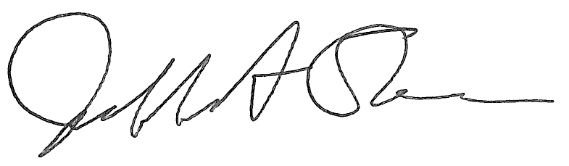

Jeffrey A. Stein Secretary of the Board of Trustees

c: Members of the Board of Trustees

President Killeen

Mr. McKeever

University Officers

Members of the Press

**Meeting of the Audit, Budget, Finance, and Facilities Committee**

**of the Board of Trustees of the University of Illinois**

University of Illinois Urbana-Champaign

I Hotel and Conference Center, Heritage Hall

1901 South First Street, Champaign, Illinois

The Audit, Budget, Finance, and Facilities Committee Meeting will be webcast live at the following address:

https://www.uis.edu/uislive

Please be advised that the times for various parts of the meeting are estimates and that the order of business may be adjusted as the meeting progresses.

**Wednesday, January 17, 2024**

2:15 p.m.* **Meeting of the Committee Convenes**

* Roll Call
* Opening Remarks by the Chair of the Committee
* *Action Item*- Approval of Minutes of Meeting of November 15, 2023

2:20 p.m. **Review Recommended Board Items for January 18, 2024, Board Meeting**

* + - Auxiliary Facilities System Revenue Bonds; Amendment of Projects Funded By Auxiliary Facilities System Revenue Bonds, Series 2018
    - Delegate Authority to Declare Intent to Reimburse In Connection With Issuance of Tax-Exempt Debt
    - Delegate Authority to the Comptroller to Approve Lease of Space for University of Illinois System Administrative Offices, Chicago, Illinois
    - Award Construction Contract for Memorial Stadium - East Joint Expansion Replacement and East Steel Painting, Division of Intercollegiate Athletics, Urbana
    - Approve Project Budget and Award Construction Contract for Illini Union Roof Replacement, Urbana
    - Purchase Recommendations

3:05 p.m. **Presentation**

* Capital Updates

3:20 p.m. **Old Business**

**New Business**

* + Next Meeting- March 27, 2024, 2:15 p.m., Student Union Ballroom, Room 224, 2251 Richard Wright Drive, Springfield

3:25 p.m. **Meeting of the Committee Adjourns When Business is Complete**