UNIVERSITY OF ILLINOIS

Urbana-Champaign • Chicago • Springfield

The Board of Trustees

352 Henry Administration Building, MC-350

506 South Wright Street

Urbana, IL 61801

January 11, 2024

**NOTICE**

On call of the Chair, a meeting of the Academic and Student Affairs Committee of the Board of Trustees of the University of Illinois will be held on Wednesday, January 17, 2024, beginning at 3:30 p.m., in the I Hotel and Conference Center, Heritage Hall, 1901 South First Street, Champaign, Illinois. (A copy of the schedule/agenda is attached.)

The meeting will also be webcast live at the following address: https://www.uis.edu/uislive.

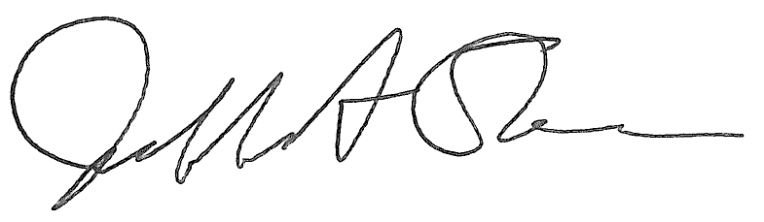

Jeffrey A. Stein Secretary of the Board of Trustees

c: Members of the Board of Trustees

President Killeen

Mr. McKeever

University Officers

Members of the Press

**Meeting of the Academic and Student Affairs Committee**

**of the Board of Trustees of the University of Illinois**

University of Illinois Urbana-Champaign

I Hotel and Conference Center, Heritage Hall

1901 South First Street, Champaign, Illinois

The Academic and Student Affairs Committee Meeting will be webcast live at the following address:

https://www.uis.edu/uislive

Please be advised that the times for various parts of the meeting are estimates and that the order of business may be adjusted as the meeting progresses.

**Wednesday, January 17, 2024**

3:30 p.m.* **Meeting of the Committee Convenes**

* Roll Call
* Opening Remarks by the Chair of the Committee
* *Action Item*- Approval of Minutes of Meeting of November 15, 2023

3:35 p.m. **Review Recommended Board Items for January 18, 2024, Board Meeting**

* Appointments to the Faculty, Administrative/Professional Staff, and Intercollegiate Athletic Staff
* Approve Tuition Rates, Academic Year 2024-2025
* Approve Student Fees for Urbana, Chicago, and Springfield, Academic Year 2024-2025
* Approve Rate Changes for University-Operated Housing Facilities, Urbana, Chicago, and Springfield, Academic Year 2024-2025
* Award Honorary Degrees, Urbana
* Amend the University of Illinois Urbana-Champaign Senate *Constitution*, Article I, Section 5, and the *Bylaws*, Urbana
* Amend the University of Illinois Urbana-Champaign Senate *Constitution*, Article III, Urbana
* Eliminate the Institute for Competitive Manufacturing, The Grainger College of Engineering, Urbana
* Rename the Department of Atmospheric Sciences, College of Liberal Arts and Sciences, Urbana
* Rename the Master of Science in Healthspan Promotion and Rehabilitation, College of Applied Health Sciences and Graduate College, Chicago
* Eliminate the Center for Public Safety and Justice, College of Urban Planning and Public Affairs, Chicago
* Establish the Government Finance Research Center, College of Urban Planning and Public Affairs, Chicago

4:05 p.m. **Presentations**

* Building Great Inclusive Teams: Not as Easy as 1, 2, 3

4:20 p.m. **Old Business**

**New Business**

* + Next Meeting- March 27, 2024, 3:30 p.m., Student Union Ballroom, Room 224, 2251 Richard Wright Drive, Springfield

4:25 p.m. **Meeting of the Committee Adjourns When Business is Completed**