UNIVERSITY OF ILLINOIS

Urbana-Champaign • Chicago • Springfield

The Board of Trustees

352 Henry Administration Building, MC-350

506 South Wright Street

Urbana, IL 61801

January 11, 2024

**NOTICE**

On call of the Chair, a meeting of the Governance, Personnel, and Ethics Committee of the Board of Trustees of the University of Illinois will be held on Wednesday, January 17, 2024, beginning at 1:20 p.m., in the I Hotel and Conference Center, Heritage Hall, 1901 South First Street, Champaign, Illinois. (A copy of the schedule/agenda is attached.)

The meeting will also be webcast live at the following address:

https://www.uis.edu/uislive.

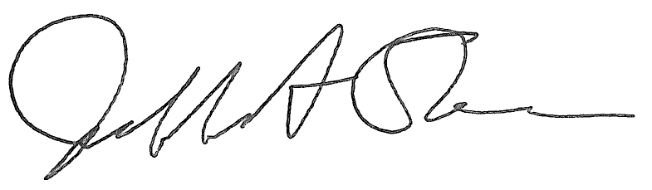

Jeffrey A. Stein

Secretary, Board of Trustees

c. Members of the Board of Trustees  
 President Killeen  
 Mr. McKeever  
 University Officers  
 Members of the Press

**Meeting of the Governance, Personnel, and Ethics Committee**

**of the Board of Trustees of the University of Illinois**

University of Illinois Urbana-Champaign

I Hotel and Conference Center, Heritage Hall

1901 South First Street, Champaign, Illinois

The Governance, Personnel, and Ethics Committee Meeting will be webcast live at the following address:

https://www.uis.edu/uislive

Please be advised that the times for various parts of the meeting are estimates and that the order of business may be adjusted as the meeting progresses.

**Wednesday, January 17, 2024**

1:20 p.m.* **Meeting of the Committee Convenes**

* Roll Call
* Opening Remarks by the Chair of the Committee
* *Action Item*- Approval of Minutes of Meeting of November 15, 2023

1:25 p.m. **Review Recommended Board Items for January 18, 2024, Board Meeting**

* Appointments to the Faculty, Administrative/Professional Staff, and Intercollegiate Athletic Staff
* Approve Revisions to the University of Illinois System Conflict of Interest Policies
* Appoint University Counsel

1:40 p.m. **Presentations**

* 2023 Ethics and Compliance Office Annual Report
* Background Check Policy Presentation and State Universities Civil Service System Update
* Legislative Update

2:05 p.m. **Old Business**

**New Business**

* + Next Meeting- March 27, 2024, 1:30 p.m., Student Union Ballroom, Room 224, 2251 Richard Wright Drive, Springfield

2:10 p.m. **Meeting of the Committee Adjourns When Business is Completed**