UNIVERSITY OF ILLINOIS

Urbana-Champaign • Chicago • Springfield

The Board of Trustees

352 Henry Administration Building, MC-350

506 South Wright Street

Urbana, IL 61801

January 17, 2024

**NOTICE – REVISED**

Today’s meeting of the UHS Committee is delayed due to inclement weather. The committee will now meet today at 4:00 pm, or 5 mins after the end of ASAC Committee, whichever comes later.

On call of the Chair, a meeting of the University Healthcare System Committee of the Board of Trustees of the University of Illinois will be held on Wednesday, January 17, 2024, beginning at **~~11:30 a.m.~~ 4:00 p.m**., in the I Hotel and Conference Center, Heritage Hall, 1901 South First Street, Champaign, Illinois. (A copy of the schedule/agenda is attached.)

The meeting will also be webcast live at the following address:

https://www.uis.edu/uislive.

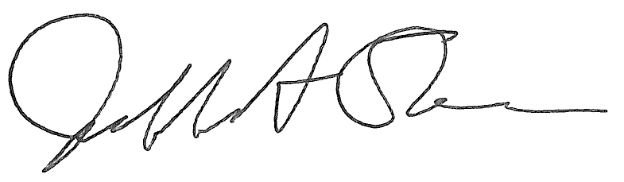

Jeffrey A. Stein

Secretary, Board of Trustees

c. Members of the Board of Trustees  
 President Killeen  
 Mr. McKeever  
 University Officers  
 Members of the Press

**Meeting of the University Healthcare System Committee**

**of the Board of Trustees of the University of Illinois**

University of Illinois Urbana-Champaign

I Hotel and Conference Center, Heritage Hall

1901 South First Street, Champaign, Illinois

The University Healthcare System Committee Meeting will be webcast live at the following address:

https://www.uis.edu/uislive

Please be advised that the times for various parts of the meeting are estimates and that the order of business may be adjusted as the meeting progresses.

**Wednesday, January 17, 2024**

**~~11:30 a.m.~~** **Meeting of the Committee Convenes**

**4:00 p.m. ⚫** Roll Call

**~~11:35 a.m.~~** **Executive Session**

**4:05 p.m.**

**~~12:35 p.m.~~ Meeting Reconvenes**

**5:05 p.m. ⚫** Opening Remarks by the Chair of the Committee

* *Action Item*- Approval of Minutes of Meeting of November 15, 2023
* Opening Remarks by Dr. Robert Barish, vice chancellor for health affairs, Chicago

**~~12:45 p.m.~~ Review Recommended Board Items for January 18, 2024, Board Meeting**

**5:15 p.m. ⚫** Approve Amendments to the Medical Staff Bylaws, University of Illinois1

Hospital and Clinics, Chicago

**~~12:50 p.m.~~** **Reports**

**5:20 p.m. ⚫** Hospital and Clinics CEO Report, including quality data and report

* + Chief Medical Officer Report

**~~1:05 p.m.~~** **Old Business**

**5:35 p.m.**

**New Business**

* + Next Meeting- March 27, 2024, 12:30 p.m., Student Union Ballroom, Room 224, 2251 Richard Wright Drive, Springfield

**~~1:10 p.m.~~** **Meeting of the Committee Adjourns When Business is Completed**

**5:40 p.m.**

**Written Reports**

* + Hospital Dashboard
  + Annual Quality & Patient Safety Report, University of Illinois Hospital and Clinics