UNIVERSITY OF ILLINOIS

Urbana-Champaign • Chicago • Springfield

The Board of Trustees

352 Henry Administration Building, MC-350

506 South Wright Street

Urbana, IL 61801

January 16, 2025

**NOTICE**

On call of the Chair, a meeting of the Governance, Personnel, and Ethics Committee of the Board of Trustees of the University of Illinois will be held on Wednesday, January 22, 2025, beginning at 1:30 p.m., in the Isadore and Sadie Dorin Forum[1], Rooms D, E, and F, 725 West Roosevelt Road, Chicago, Illinois. (A copy of the schedule/agenda is attached.)

The meeting will also be webcast live at the following address:

https://www.uis.edu/uislive.

The Board of Trustees meetings are open to the public, pursuant to Illinois state law and the Board’s own procedures. Attendees will not be permitted to knowingly interfere with or impede, through disruptions or other means, the Board’s performance of its institutional duties. Individuals who disrupt the meeting will be asked to leave. If the disruption continues following due notice to depart the meeting space, individuals will be removed from the premises. Individuals who disrupt the Board’s performance of its institutional duties or refuse to leave the meeting may be in violation of state laws, including but not limited to the Illinois Interference with a Public Institution of Education Act.

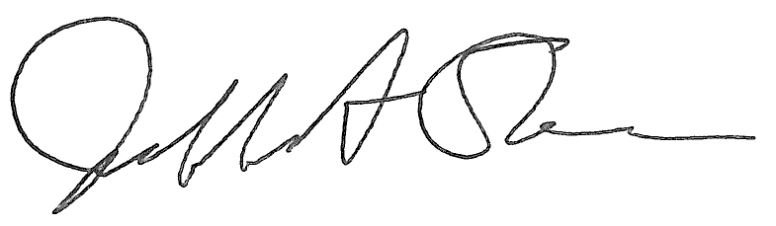

Jeffrey A. Stein

Secretary, Board of Trustees

c. Members of the Board of Trustees  
 President Killeen  
 Mr. McKeever  
 University Officers  
 Members of the Press

**Meeting of the Governance, Personnel, and Ethics Committee**

**of the Board of Trustees of the University of Illinois**

University of Illinois Chicago

Isadore and Sadie Dorin Forum, Rooms D, E, and F

725 West Roosevelt Road, Chicago, Illinois

The Governance, Personnel, and Ethics Committee Meeting will be webcast live at the following address:

https://www.uis.edu/uislive

Please be advised that the times for various parts of the meeting are estimates and that the order of business may be adjusted as the meeting progresses.

**Wednesday, January 22, 2025**

1:30 p.m. **Meeting of the Committee Convenes**

* Roll Call
* Opening Remarks by the Chair of the Committee
* *Action Item*- Approval of Minutes of Meeting of November 13, 2024

1:35 p.m. **Review Recommended Board Items for January 23, 2025, Board Meeting**

* Appointments to the Faculty, Administrative/Professional Staff, and Intercollegiate Athletic Staff
* Amend Designation of the President’s House
* Appoint Director, Department of Intercollegiate Athletics, Chicago
* Reappoint Member to the Advisory Board, Division of Specialized Care for Children (DSCC) in Springfield, Chicago

1:50 p.m. **Presentation**

* Annual Background Check Policy Presentation
* Legislative Update

2:05 p.m. **Old Business**

**New Business**

* + Next Meeting- March 19, 2025, 1:30 p.m., Student Union Ballroom, Room 224, 2251 Richard Wright Drive, Springfield

2:10 p.m. **Meeting of the Committee Adjourns When Business is Completed**

1. The UIC Dorin Forum does not permit graphic boards or posters inside the facility. All bags will be subject to inspection.