Reported to the Board of Trustees

January 26, 2023

# CY2022 Annual Quality and Patient Safety Plan

**University of Illinois Board of Trustees**

**January 2023**

The Quality and Patient Safety program at the University of Illinois Hospital & Health Sciences System (UI Health) supports quality and safety improvement for UI Health’s entire scope of clinical operations including our hospital, clinics, and Mile Square Health Center.

**Geographic location, community, and population served**

The University of Illinois Hospital & Clinics (UIH) is in Chicago’s near Southwest side, in the heart of the Illinois Medical District. It includes a 450 licensed bed tertiary Medical Center, outpatient facility, and specialty clinics. University Village is a group of clinics providing a variety of primary and specialty care services. In January 2022, a new health collaborative opened to serve the Gage Park (55th and Pulaski) and West Elsden communities, offering comprehensive care. UIH serves the people of the surrounding community as well as people from the state of Illinois and beyond who access the specialty services provided by an academic medical center, renowned within the state and beyond its borders. While the primary mission is to provide high quality medical care to patients, UIH also exists to support essential teaching and research functions of the academic units of the University’s seven health sciences colleges.

**Care, Treatment and Services Provided**

Services provided at UIH include a full range of medical and surgical specialties. Specialty programs include a Level III high risk nursery and a Level II Emergency Department as well as an OB Emergency Department complete with two operating rooms on the 4th floor. Critical care units include neuro-medical-surgical intensive care, medical intensive care (which includes care post open heart surgery), pediatric intensive care, and neonatal intensive care (NNICU) units. Inpatient and outpatient cancer and dialysis services are provided. Care for solid organ transplants is provided with post-surgical care on an identified unit. A Blood and Marrow Transplant Unit includes 20 beds. Inpatient psychiatric services are provided on two units: one for adults, and another for adolescents aged 9 to 17 referred to UIH by the Department of Children and Family Services. The adult psychiatric unit includes four medical beds. Intensive Outpatient Program for Behavioral Health services are provided in the Neuropsychiatric clinic. Inpatient and outpatient dialysis services are provided. Pediatric services are provided under a recognized children’s hospital within UIH. Surgical services are provided in the main operating room (OR) and the Specialty Care Building. Outpatient care is provided in a full range of primary care and specialty clinics, including medical and surgical specialties. There are fourteen Federally Qualified Health Centers, organized under Mile Square, with administrative links to UIH.

**UI Health Mission**

The University of Illinois Hospital and Clinics is a patient centered organization. Providing safe, high-quality and cost-effective care for our patients is our foremost responsibility. The care of our patients and their families will always be at the heart of our mission. The Mission of UI Health is to advance healthcare for everyone through outstanding clinical care, education, research, and social responsibility. UI Health strives to provide excellent outcomes and excellent experience.

**Quality & Safety Transformation**

UI Health has embarked on a transformation of the care provided along with the infrastructure of quality and safety across the organization. This has been titled UI Health Quality and Safety Transformation (QST).

**Culture of Safety Survey**

As part of the QST, UI Health has chosen a standard definition for the “Culture of Safety” and communicating this across the organization in an action plan in response to the FY2022 culture of safety survey. Culture of Safety at UI Health is defined as:

* Healthcare professionals are held accountable for unprofessional conduct but not punished for human mistakes.
* Errors are identified and mitigated before harm occurs.
* Systems are in place to enable staff to learn from errors and near misses and prevent a recurrence.

# Quality & Patient Safety Goals

The University of Illinois Health (UIH) Quality & Patient Safety priorities and performance targets have been set based on annual risk assessment that includes the historic performance from the prior fiscal year as well as internal and external benchmarks.

UI Health FY23 Quality & Safety Goals are as follows:

* Reduce patient safety events
* Reduce employee safety events
* Improve inpatient experience scores
* Improve outpatient experience scores
* Improve net revenue
* Manage operating costs

UI Health has chosen True North Metrics as part of the QST for FY2023 to ensure alignment with how we are evaluated by regulatory and other rating organizations. These are identified as the key areas of performance needed to improve patient safety and patient experience. Advancement in these areas will improve net revenue and operating costs through efficient high-quality care.

Leaders are asked to choose individual or departmental goals from the True North Metrics below:

**UI Health FY23 True North Metrics**

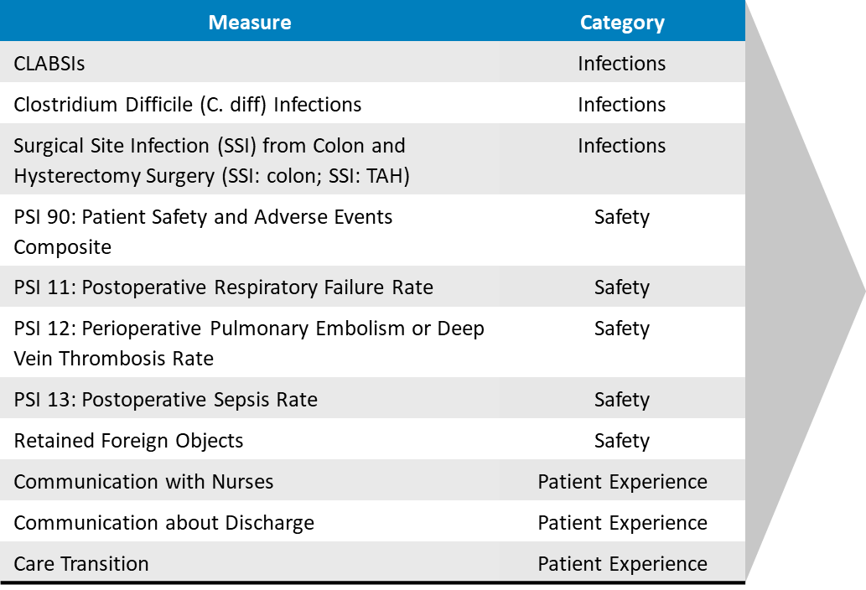

PSI 90 Composite comprised of:

* PSI 03 Pressure Ulcer Rate
* PSI 06 Iatrogenic Pneumothorax Rate
* PSI 08 In-Hospital Fall with Hip Fracture Rate
* PSI 09 Perioperative Hemorrhage or Hematoma Rate
* PSI 10 Post-Operative Acute Kidney Injury Requiring Dialysis Rate
* PSI 11 Postoperative Respiratory Failure Rate
* PSI 12 Perioperative Pulmonary Embolism or Deep Vein Thrombosis Rate
* PSI 13 Postoperative Sepsis Rate
* PSI 14 Postoperative Wound Dehiscence Rate
* PSI 15 Unrecognized Accidental Puncture or Laceration Rate

*Staff Wellness & Safety Events Goals:*

* Improve practitioner engagement
* Improve employee engagement
* Reduce total employee harms
* Reduce sharps injuries
* Reduce patient and equipment handling injury
* Reduce slips, trips, and falls
* Reduce physical alterations

*Patient Quality Health Equity Initiatives*

This program is supported through an incentive-based collaboration with Blue Cross & Blue Shield. The quality health outcomes component of the program tasks UIH with identify four inpatient and four outpatient quality health outcomes and to decrease disparities across race and ethnic demographics. UIH chose the following quality outcomes based on historical performance and comparative benchmarks:

* Reduce colon and hysterectomy procedure surgical site infections
* Reduce post-operative sepsis
* Reduce post-operative venous thrombosis
* Reduce hospital acquired pressure ulcers
* Reduce time patients spend in the ED before being sent home
* Reduce ED patients leaving without being seen
* Reduce 7-day admission rate after outpatient colonoscopy
* Reduce admissions after receiving outpatient chemotherapy

# Annual Summary & Department Level Goals

The above goals have been determined through evaluation of FY22 performance and the work of Quality and Safety Committees and Departments as outlined below with information on FY22 work and ongoing and planned work for FY23.

## **Quality and Safety Transformation Re-Structure of:**

Replacing QSSL is the below structure to ensure accountability and reporting to the Board of Trustees:

**UI Health Quality Executive Steering Committee (ESC)**

**Purpose**: The purpose of the UI Health Quality Executive Steering Committee (ESC) is to provide direction and oversight of activities conducted by the UI Health Systems Quality Committee (HSQC) to ensure the organization provides safe, high quality patient-centered clinical care in alignment with the UI Health’s Mission and the values of Inclusion, Compassion, Accountability, Respect, and Excellence.

**UI Health System Quality Committee (HSQC)**

**Purpose**: The purpose of the UI Health System Quality Committee is to provide governance in collaborative support to the ESC to ensure that quality of clinical care, patient safety, and excellence in patient experience are provided throughout the organization in agreement with the Mission and the values of Inclusion, Compassion, Accountability, Respect, and Excellence set forth by UI Health.

# Quality & Patient Safety Division

The Quality & Patient Safety division comprises seven teams:

* Accreditation & Clinical Compliance:
* Clinical Documentation Improvement
* Health Information Management and Privacy Office
* Infection Prevention & Control
* Patient Safety & Risk Management
* Quality Performance & Improvement: Interim Director named November 2022
* Clinical Ethics Service

These teams work closely together to optimize alignment of activities and the magnitude of collective impact.

**Committee and Task Force Charters are being updated and the proposed structure of UI Health Quality and Safety final recommendations will be made to the Board of Trustees in March of 2023.**

**Education:**

A training program for senior leaders on the QST was given on November 1st-3rd. This program was designed to educate key staff on the process improvement tools and application for achieving change in outcomes. The primary QAPI method will be DMAIC (Define—Measure—Analyze—Improve—Control)

**Resources for Sustained Improvement:**

Each quality committee or task force will have a quality specialist, clinical informatics (physician, nursing, or pharmacy as relevant), and quality specialist. Process improvement tools have been standardized and available for all task force and committee work