UNIVERSITY OF ILLINOIS

Urbana-Champaign • Chicago • Springfield

The Board of Trustees

352 Henry Administration Building, MC-350

506 South Wright Street

Urbana, IL 61801

July 3, 2024

**NOTICE**

On call of the Chair, a meeting of the Academic and Student Affairs Committee of the Board of Trustees of the University of Illinois will be held on Wednesday, July 10, 2024, beginning at 3:30 p.m., in the Isadore and Sadie Dorin Forum[1], Rooms D, E, and F, 725 West Roosevelt Road, Chicago, Illinois. (A copy of the schedule/agenda is attached.)

The meeting will also be webcast live at the following address: https://www.uis.edu/uislive.

The Board of Trustees meetings are open to the public, pursuant to Illinois state law and the Board’s own procedures. Attendees will not be permitted to knowingly interfere with or impede, through disruptions or other means, the Board’s performance of its institutional duties. Individuals who disrupt the meeting will be asked to leave. If the disruption continues following due notice to depart the meeting space, individuals will be removed from the premises. Individuals who disrupt the Board’s performance of its institutional duties or refuse to leave the meeting may be in violation of state laws, including but not limited to the Illinois Interference with a Public Institution of Education Act.

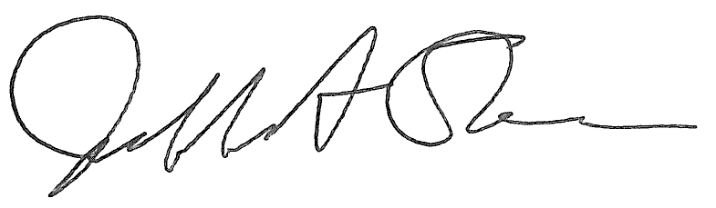

Jeffrey A. Stein Secretary of the Board of Trustees

c: Members of the Board of Trustees

President Killeen

Mr. McKeever

University Officers

Members of the Press

**Meeting of the Academic and Student Affairs Committee**

**of the Board of Trustees of the University of Illinois**

University of Illinois Chicago

Isadore and Sadie Dorin Forum, Rooms D, E, and F

725 West Roosevelt Road, Chicago, Illinois

The Academic and Student Affairs Committee Meeting will be webcast live at the following address:

https://www.uis.edu/uislive

Please be advised that the times for various parts of the meeting are estimates and that the order of business may be adjusted as the meeting progresses.

**Wednesday, July 10, 2024**

3:30 p.m.* **Meeting of the Committee Convenes**

* Roll Call
* Opening Remarks by the Chair of the Committee
* *Action Item*- Approval of Minutes of Meeting of May 15, 2024

3:35 p.m. **Review Recommended Board Items for July 11, 2024, Board Meeting**

* Appointments to the Faculty, Administrative/Professional Staff, and Intercollegiate Athletic Staff
* Promotions in Academic Rank and Change in Tenure, 2024-2025
* Establish the Connie Frank CARE (Coordination, Assistance, Response and Education) Center, Office of the Dean of Students, Urbana
* Appoint Interim Dean, College of Fine and Applied Arts, Urbana
* Appoint Dean, College of Fine and Applied Arts, Urbana
* Appoint Dean, Gies College of Business, Urbana
* Appoint Interim Dean, School of Labor and Employment Relations, Urbana
* Establish the Bachelor of Science in Chemical Engineering + Data Science, College of Liberal Arts and Sciences, Urbana
* Establish the Bachelor of Science in Liberal Arts and Sciences in Molecular and Cellular Biology + Data Science, College of Liberal Arts and Sciences, Urbana
* Establish the Master of Science in Global Studies, College of Liberal Arts and Sciences and the Graduate College, Urbana
* Establish the Master of Science in Human Resource Management, College of Business Administration and the Graduate College
* Eliminate the Bachelor of Science in the Teaching of Physics, College of Liberal Arts and Sciences, Chicago
* Name the Herbert M. and Carol H. Retzky College of Pharmacy, Chicago

4:05 p.m. **Presentations**

* Engaging Communities through Youth Mentoring

4:20 p.m. **Old Business**

**New Business**

* + Next Meeting- September 18, 2024, 3:30 p.m., I Hotel and Conference Center, Illinois Ballroom, 1901 South First Street, Champaign

4:25 p.m. **Meeting of the Committee Adjourns When Business is Completed**

1. The UIC Dorin Forum does not permit graphic boards or posters inside the facility. All bags will be subject to inspection.