UNIVERSITY OF ILLINOIS
Urbana-Champaign • Chicago • Springfield

The Board of Trustees
352 Henry Administration Building, MC-350
506 South Wright Street
Urbana, IL 61801
July 9, 2026

NOTICE

On call of the Chair, a meeting of the Governance, Personnel, and Ethics Committee of the Board of Trustees of the University of Illinois will be held on Wednesday, July 15, 2026, beginning at 10:30 a.m., in the I Hotel and Conference Center, Illinois Ballroom, 1900 South First Street, Champaign, Illinois. (A copy of the schedule/agenda is attached.)

The meeting will also be webcast live at the following address:
https://www.uis.edu/uislive.

The Board of Trustees meetings are open to the public, pursuant to Illinois state law and the Board’s own procedures. Attendees will not be permitted to knowingly interfere with or impede, through disruptions or other means, the Board’s performance of its institutional duties. Individuals who disrupt the meeting will be asked to leave. If the disruption continues following due notice to depart the meeting space, individuals will be removed from the premises. Individuals who disrupt the Board’s performance of its institutional duties or refuse to leave the meeting may be in violation of state laws, including but not limited to the Illinois Interference with a Public Institution of Education Act.

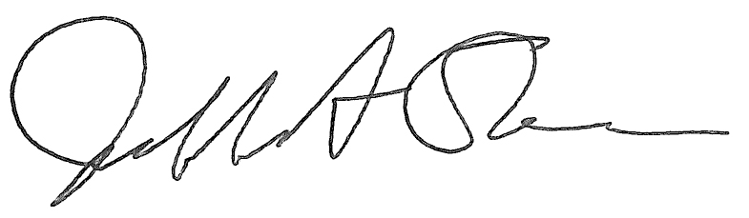
Jeffrey A. Stein
Secretary, Board of Trustees

c. Members of the Board of Trustees
President Killeen
Mr. Engle
University Officers
Members of the Press
Meeting of the Governance, Personnel, and Ethics Committee
of the Board of Trustees of the University of Illinois

University of Illinois Urbana-Champaign
I Hotel and Conference Center, Illinois Ballroom
1900 South First Street, Champaign, Illinois

The Governance, Personnel, and Ethics Committee Meeting will be webcast live at the following address:
https://www.uis.edu/uislive

Please be advised that the times for various parts of the meeting are estimates and that the order of business may be adjusted as the meeting progresses.

Wednesday, July 15, 2026
10:30 a.m. Meeting of the Committee Convenes
- Roll Call
- Opening Remarks by the Chair of the Committee
- Action Item- Approval of Minutes of Meeting of May 20, 2026

10:35 a.m. Review Recommended Board Items for July 16, 2026, Board Meeting
- Appointments to the Faculty, Administrative/Professional Staff, and Intercollegiate Athletic Staff
- Approve Memorandum of Understanding with University of Illinois Foundation
- Amend Designation of the President’s House
- Amend Multiyear Contract with Director, Division of Intercollegiate Athletics, Urbana
- Amend Multiyear Contract, Head Coach, Men’s Basketball, Chicago

10:50 a.m. Presentations
- Illinois Quantum and Microelectronics Park, LLC Update
- Enterprise Risk Management Annual Report
- Legislative Update

11:10 a.m. Old Business

New Business
  - Next Meeting- September 16, 2026, 10:00 a.m., Alice Campbell Alumni Center Ballroom, 601 South Lincoln Avenue, Urbana

11:15 a.m. Meeting of the Committee Adjourns When Business is Completed

Per hotel management, the I Hotel and Conference Center does not permit signs inside the facility. All bags will be subject to inspection.

