UNIVERSITY OF ILLINOIS

Urbana-Champaign • Chicago • Springfield

The Board of Trustees

352 Henry Administration Building, MC-350

506 South Wright Street

Urbana, IL 61801

July 10, 2025

**NOTICE**

On call of the Chair, a meeting of the University Healthcare System Committee of the Board of Trustees of the University of Illinois will be held on Wednesday, July 16, 2025, beginning at 12:30 p.m., in the Isadore and Sadie Dorin Forum[1], Rooms D, E, and F, 725 West Roosevelt Road, Chicago, Illinois. (A copy of the schedule/agenda is attached.)

The meeting will also be webcast live at the following address:

https://www.uis.edu/uislive.

The Board of Trustees meetings are open to the public, pursuant to Illinois state law and the Board’s own procedures. Attendees will not be permitted to knowingly interfere with or impede, through disruptions or other means, the Board’s performance of its institutional duties. Individuals who disrupt the meeting will be asked to leave. If the disruption continues following due notice to depart the meeting space, individuals will be removed from the premises. Individuals who disrupt the Board’s performance of its institutional duties or refuse to leave the meeting may be in violation of state laws, including but not limited to the Illinois Interference with a Public Institution of Education Act.

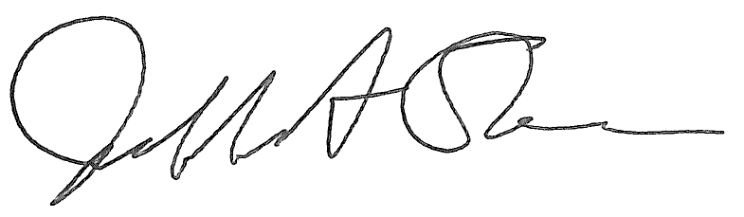

Jeffrey A. Stein

Secretary, Board of Trustees

c. Members of the Board of Trustees  
 President Killeen  
 Mr. McKeever  
 University Officers  
 Members of the Press

**Meeting of the University Healthcare System Committee**

**of the Board of Trustees of the University of Illinois**

University of Illinois Chicago

Isadore and Sadie Dorin Forum, Rooms D, E, and F

725 West Roosevelt Road, Chicago, Illinois

The University Healthcare System Committee Meeting will be webcast live at the following address:

https://www.uis.edu/uislive

Please be advised that the times for various parts of the meeting are estimates and that the order of business may be adjusted as the meeting progresses.

**Wednesday, July 16, 2025**

12:30 p.m. **Meeting of the Committee Convenes**

* Roll Call

12:35 p.m. **Executive Session**

12:50 p.m. **Meeting Reconvenes**

* Opening Remarks by the Chair of the Committee
* *Action Item*- Approval of Minutes of Meeting of May 21, 2025
* Opening Remarks by Dr. Robert Barish, vice chancellor for health affairs, Chicago

12:55 p.m. **Review Recommended Board Items for July 17, 2025, Board Meeting**

* Approve Minutes of the Board of Trustees as the Sole Member of Wolcott, Wood and Taylor, Inc., Meeting

1:00 p.m. **Reports**

* + Hospital and Clinics CEO Report, including quality metrics
  + Chief Medical Officer Report
  + Compliance Update

1:20 p.m. **Old Business**

**New Business**

* Next Meeting- September 17, 2025, 12:30 p.m., I Hotel and Conference Center, Heritage Hall, 1901 South First Street, Champaign

1:25 p.m. **Meeting of the Committee Adjourns When Business is Completed**

**Written Reports**

* + Hospital Dashboard
  + WWT Report

1. The UIC Dorin Forum does not permit graphic boards or posters inside the facility. All bags will be subject to inspection.