UNIVERSITY OF ILLINOIS

Urbana-Champaign • Chicago • Springfield

The Board of Trustees

352 Henry Administration Building, MC-350

506 South Wright Street

Urbana, IL 61801

July 13, 2023

**NOTICE**

On call of the Chair, a meeting of the Audit, Budget, Finance, and Facilities Committee of the Board of Trustees of the University of Illinois will be held on Wednesday, July 19, 2023, beginning at 2:15 p.m., in the Isadore and Sadie Dorin Forum, Rooms D, E, and F, 725 West Roosevelt Road, Chicago, Illinois. (A copy of the schedule/agenda is attached.)

The meeting will also be webcast live at the following address:

https://www.uis.edu/uislive.

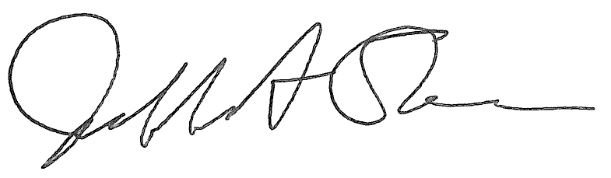

Jeffrey A. Stein Secretary of the Board of Trustees

c: Members of the Board of Trustees

President Killeen

Mr. McKeever

University Officers

Members of the Press

**Meeting of the Audit, Budget, Finance, and Facilities Committee**

**of the Board of Trustees of the University of Illinois**

University of Illinois Chicago

Isadore and Sadie Dorin Forum, Rooms D, E, and F

725 West Roosevelt Road, Chicago, Illinois

The Audit, Budget, Finance, and Facilities Committee Meeting will be webcast live at the following address:

https://www.uis.edu/uislive

Please be advised that the times for various parts of the meeting are estimates and that the order of business may be adjusted as the meeting progresses.

**Wednesday, July 19, 2023**

2:15 p.m.* **Meeting of the Committee Convenes**

* Roll Call
* Opening Remarks by the Chair of the Committee
* *Action Item*- Approval of Minutes of Meeting of May 17, 2023

2:20 p.m. **Review Recommended Board Items for July 20, 2023, Board Meeting**

* Approve Revision to the University’s Liability Self-Insurance Plan
* Approve Development Agreement for the University of Illinois Research Park, Urbana
* Approve Design for Small Animal Clinic Oncology Center Addition, Veterinary Teaching Hospital, Urbana
* Amend Professional Services Consultant Contract for Illinois Autonomous and Connected Track Facility, Urbana
  + - Purchase Recommendations

2:40 p.m. **Presentations**

* Small Animal Clinic Oncology Center Addition Design Presentation, Veterinary Teaching Hospital
* RSM FY2023 Audit Plan Presentation
* University Audits Two-Year Internal Audit Plan for Fiscal Years 2024-2025

3:15 p.m. **Old Business**

**New Business**

* + Next Meeting- September 20, 2023, 2:15 p.m., Student Dining and Residential Programs Building, Multi-Purpose Room 2025 A, B, and C, 301 East Gregory Drive, Champaign

3:20 p.m. **Meeting of the Committee Adjourns When Business is Complete**