UNIVERSITY OF ILLINOIS

Urbana-Champaign • Chicago • Springfield

The Board of Trustees

352 Henry Administration Building, MC-350

506 South Wright Street

Urbana, IL 61801

July 13, 2023

**NOTICE**

On call of the Chair, a meeting of the Academic and Student Affairs Committee of the Board of Trustees of the University of Illinois will be held on Wednesday, July 19, 2023, beginning at 3:30 p.m., in the Isadore and Sadie Dorin Forum, Rooms D, E, and F, 725 West Roosevelt Road, Chicago, Illinois. (A copy of the schedule/agenda is attached.)

The meeting will also be webcast live at the following address:

https://www.uis.edu/uislive.

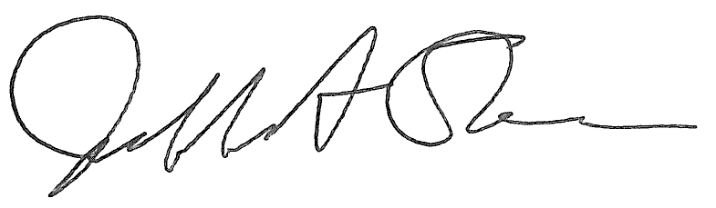

Jeffrey A. Stein Secretary of the Board of Trustees

c: Members of the Board of Trustees

President Killeen

Mr. McKeever

University Officers

Members of the Press

**Meeting of the Academic and Student Affairs Committee**

**of the Board of Trustees of the University of Illinois**

University of Illinois Chicago

Isadore and Sadie Dorin Forum, Rooms D, E, and F

725 West Roosevelt Road, Chicago, Illinois

The Academic and Student Affairs Committee Meeting will be webcast live at the following address:

https://www.uis.edu/uislive

Please be advised that the times for various parts of the meeting are estimates and that the order of business may be adjusted as the meeting progresses.

**Wednesday, July 19, 2023**

3:30 p.m.* **Meeting of the Committee Convenes**

* Roll Call
* Opening Remarks by the Chair of the Committee
* *Action Item*- Approval of Minutes of Meeting of May 17, 2023

3:35 p.m. **Review Recommended Board Items for July 20, 2023, Board Meeting**

* Appointments to the Faculty, Administrative/Professional Staff, and Intercollegiate Athletic Staff
* Promotions in Academic Rank and Change in Tenure, 2023-2024
* Approve Pilot Tuition Program for St. Charles and St. Louis Counties in Missouri and Scott County in Iowa, Springfield
* Approve Revocation of Doctor of Philosophy Degree, Urbana
* Appoint Dean, School of Social Work, Urbana
* Appoint Interim Dean, College of Law, Urbana
* Extend Term, Dean, College of Media, Urbana
* Extend Term, Dean, College of Fine and Applied Arts, Urbana
* Establish the Center for Culturally Responsive Evaluation and Assessment as a Permanent Center, College of Education, Urbana
* Establish the Center for Global Studies as a Permanent Center, College of Liberal Arts and Sciences, Urbana
* Establish the Center for South Asian and Middle Eastern Studies as a Permanent Center, College of Liberal Arts and Sciences, Urbana
* Establish the Illinois Global Institute as a Permanent Institute, College of Liberal Arts and Sciences, Urbana
* Establish the Women and Gender in Global Perspectives Program as a Permanent Center, College of Liberal Arts and Sciences, Urbana
* Eliminate the Master of Arts in Teaching of Social Studies, College of Liberal Arts and Sciences and the Graduate College, Urbana
* Appoint Provost and Vice Chancellor for Academic Affairs, Chicago
* Appoint Dean, College of Business Administration, Chicago
* Eliminate the Bachelor of Arts in Liberal Arts and Sciences, Major in Classical Languages and Literatures, College of Liberal Arts and Sciences, Chicago
* Establish the Bachelor of Music in Music Education, College of Architecture, Design, and the Arts, Chicago
* Eliminate University of Illinois College of Medicine at Urbana-Champaign, University of Illinois College of Medicine, Chicago
* Establish the Center for Population Health, Health Equity, Outcomes and Informatics Research (C4Health Research), University of Illinois College of Medicine Peoria, Chicago
* Establish the Doctor of Philosophy in Health Professions Education, University of Illinois College of Medicine and Graduate College
* Establish the Institute for Healthcare Delivery Design, Office of the Vice Chancellor for Health Affairs, Chicago
* Appoint Vice Chancellor for Academic Affairs and Provost, Springfield
* Appoint Vice Chancellor for Student Affairs, Springfield
* Appoint Dean, College of Liberal Arts and Social Sciences, Springfield
* Appoint Interim Dean, College of Health, Science and Technology, Springfield

4:15 p.m. **Presentations**

* Generative AI Update

4:25 p.m. **Old Business**

**New Business**

* + Next Meeting- September 20, 2023, 3:30 p.m., Student Dining and Residential Programs Building, Multi-Purpose Room 2025 A, B, and C, 301 East Gregory Drive, Champaign

4:30 p.m. **Meeting of the Committee Adjourns When Business is Completed**