UNIVERSITY OF ILLINOIS

Urbana-Champaign • Chicago • Springfield

The Board of Trustees

352 Henry Administration Building, MC-350

506 South Wright Street

Urbana, IL 61801

July 13, 2023

**NOTICE**

On call of the Chair, a meeting of the Governance, Personnel, and Ethics Committee of the Board of Trustees of the University of Illinois will be held on Wednesday, July 19, 2023, beginning at 1:30 p.m., in the Isadore and Sadie Dorin Forum, Rooms D, E, and F, 725 West Roosevelt Road, Chicago, Illinois. (A copy of the schedule/agenda is attached.)

The meeting will also be webcast live at the following address:

https://www.uis.edu/uislive.

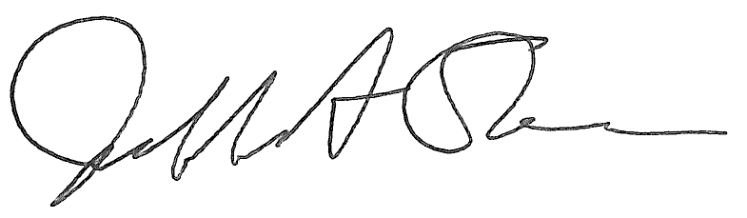

Jeffrey A. Stein

Secretary, Board of Trustees

c. Members of the Board of Trustees  
 President Killeen  
 Mr. McKeever  
 University Officers  
 Members of the Press

**Meeting of the Governance, Personnel, and Ethics Committee**

**of the Board of Trustees of the University of Illinois**

University of Illinois Chicago

Isadore and Sadie Dorin Forum, Rooms D, E, and F

725 West Roosevelt Road, Chicago, Illinois

The Governance, Personnel, and Ethics Committee Meeting will be webcast live at the following address:

https://www.uis.edu/uislive

Please be advised that the times for various parts of the meeting are estimates and that the order of business may be adjusted as the meeting progresses.

**Wednesday, July 19, 2023**

1:30 p.m.* **Meeting of the Committee Convenes**

* Roll Call
* Opening Remarks by the Chair of the Committee
* *Action Item*- Approval of Minutes of Meeting of May 17, 2023

1:35 p.m. **Review Recommended Board Items for July 20, 2023, Board Meeting**

* Appointments to the Faculty, Administrative/Professional Staff, and Intercollegiate Athletic Staff
* Amend the University of Illinois *Statutes*
* Revisions to the University of Illinois System Policy on Background Checks
* Appoint Members to the Athletic Board, Urbana
* Appoint members and renew terms to the University of Illinois Research Park, LLC, Board of Managers
* Appoint Interim Vice Chancellor for Finance and Administration, Springfield
* Approve Minutes of the Board of Trustees as the Sole Member of Prairieland Energy, Inc., Meeting
* Appoint Directors, Prairieland Energy, Inc.

1:45 p.m. **Presentations**

* Enterprise Risk Management Annual Report and Digital Risk Update
* Legislative Update

2:00 p.m. **Old Business**

**New Business**

* + Next Meeting- September 20, 2023, 1:30 p.m., Student Dining and Residential Programs Building, Multi-Purpose Room 2025 A, B, and C, 301 East Gregory Drive, Champaign

2:05 p.m. **Meeting of the Committee Adjourns When Business is Completed**