UNIVERSITY OF ILLINOIS
Urbana-Champaign • Chicago • Springfield

The Board of Trustees
352 Henry Administration Building, MC-350
506 South Wright Street
Urbana, IL 61801
March 12, 2026

NOTICE

On call of the Chair, a meeting of the Audit, Budget, Finance, and Facilities Committee of the Board of Trustees of the University of Illinois will be held on Wednesday, March 18, 2026, beginning at 1:45 p.m., in the Student Union Ballroom, Room 224, 2251 Richard Wright Drive, Springfield, Illinois. (A copy of the schedule/agenda is attached.)

The meeting will also be webcast live at the following address:
https://www.uis.edu/uislive.

The Board of Trustees meetings are open to the public, pursuant to Illinois state law and the Board’s own procedures. Attendees will not be permitted to knowingly interfere with or impede, through disruptions or other means, the Board’s performance of its institutional duties. Individuals who disrupt the meeting will be asked to leave. If the disruption continues following due notice to depart the meeting space, individuals will be removed from the premises. Individuals who disrupt the Board’s performance of its institutional duties or refuse to leave the meeting may be in violation of state laws, including but not limited to the Illinois Interference with a Public Institution of Education Act.

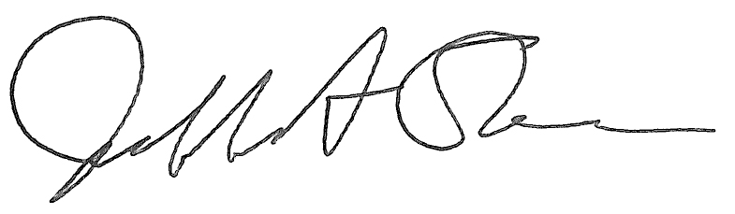
Jeffrey A. Stein Secretary of the Board of Trustees

c: Members of the Board of Trustees
President Killeen
Mr. Engle
University Officers
Members of the Press
Meeting of the Audit, Budget, Finance, and Facilities Committee
of the Board of Trustees of the University of Illinois

University of Illinois Springfield
Student Union Ballroom, Room 224,
2251 Richard Wright Drive, Springfield, Illinois

The Audit, Budget, Finance, and Facilities Committee Meeting will be webcast live at the following address:
https://www.uis.edu/uislive

Please be advised that the times for various parts of the meeting are estimates and that the order of business may be adjusted as the meeting progresses.

Wednesday, March 18, 2026
1:45 p.m.* Meeting of the Committee Convenes
- Roll Call
- Opening Remarks by the Chair of the Committee
- Action Item- Approval of Minutes of Meeting of January 14, 2026

1:50 p.m. Review Recommended Board Items for March 19, 2026, Board Meeting
    - Approve Project Budget for Renovation, Altgeld Hall and Replacement, Illini Hall, Urbana (Capital Development Board Project)
    - Approve Project Budget and Amend Professional Services Consultant Contract for Ikenberry Residence Hall 4 and Demo 0091, 0092, Urbana
    - Approve Energy Conservation Project and Award Professional and Construction Services Contract, College of ACES Buildings, Urbana
    - Employ Architect/Engineer for Thomas M. Siebel Center for Computer Science Addition, Urbana (Capital Development Board Project)
    - Purchase Recommendations

2:20 p.m. Presentation
- Summary of Internal Audit Activity Through Second Quarter Ended December 31, 2025

2:30 p.m. Old Business

New Business
  - Next Meeting- May 20, 2026, 1:45 p.m., I Hotel and Conference Center, Illinois Ballroom, 1901 South First Street, Champaign

2:35 p.m. Meeting of the Committee Adjourns When Business is Complete

