UNIVERSITY OF ILLINOIS
Urbana-Champaign • Chicago • Springfield

The Board of Trustees
352 Henry Administration Building, MC-350
506 South Wright Street
Urbana, IL 61801
March 12, 2026
NOTICE

On call of the Chair, a meeting of the Academic and Student Affairs Committee of the Board of Trustees of the University of Illinois will be held on Wednesday, March 18, 2026, beginning at 2:45 p.m., in the Student Union Ballroom, Room 224, 2251 Richard Wright Drive, Springfield, Illinois. (A copy of the schedule/agenda is attached.)

The meeting will also be webcast live at the following address: https://www.uis.edu/uislive.

The Board of Trustees meetings are open to the public, pursuant to Illinois state law and the Board’s own procedures. Attendees will not be permitted to knowingly interfere with or impede, through disruptions or other means, the Board’s performance of its institutional duties. Individuals who disrupt the meeting will be asked to leave. If the disruption continues following due notice to depart the meeting space, individuals will be removed from the premises. Individuals who disrupt the Board’s performance of its institutional duties or refuse to leave the meeting may be in violation of state laws, including but not limited to the Illinois Interference with a Public Institution of Education Act.

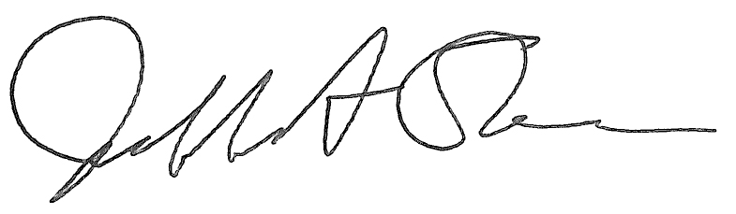
Jeffrey A. Stein Secretary of the Board of Trustees

c: Members of the Board of Trustees
President Killeen
Mr. Engle
University Officers
Members of the Press

Meeting of the Academic and Student Affairs Committee
of the Board of Trustees of the University of Illinois

University of Illinois Springfield
Student Union Ballroom, Room 224,
2251 Richard Wright Drive, Springfield, Illinois
The Academic and Student Affairs Committee Meeting will be webcast live at the following address:
https://www.uis.edu/uislive
Please be advised that the times for various parts of the meeting are estimates and that the order of business may be adjusted as the meeting progresses.

Wednesday, March 18, 2026
2:45 p.m.* Meeting of the Committee Convenes
- Roll Call
- Opening Remarks by the Chair of the Committee
- Action Item- Approval of Minutes of Meeting of January 14, 2026

2:50 p.m. Review Recommended Board Items for March 19, 2026, Board Meeting
- Appointments to the Faculty, Administrative/Professional Staff, and Intercollegiate Athletic Staff
- Approve Sabbatical Leaves of Absence, Academic Year 2026-2027
- Approve Student Health Insurance Rates, Urbana, Chicago, and Springfield, Academic Year 2026-2027
- Approve Transportation Fees, Chicago, Academic Year 2026-2027
- Appoint Associates to the Center for Advanced Study, Urbana
- Appoint Fellows to the Center for Advanced Study, Urbana
- Establish the Bachelor of Science in Public Health, College of Applied Health Sciences, Urbana
- Eliminate the Bachelor of Science in Community Health, College of Applied Health Sciences, Urbana
- Establish the Doctor of Social Work in Social Work, School of Social Work and the Graduate College, Urbana
- Establish the Master of Science in Law, College of Law and the Graduate College, Urbana
- Establish the Master of Science in Neuroscience, College of Liberal Arts and Sciences and the Graduate College, Urbana
- Establish the Master of Science in Policy Economics, College of Liberal Arts and Sciences and the Graduate College, Urbana
- Establish the Master of Science in Economic Modeling, AI, and Data Science, College of Liberal Arts and Sciences and the Graduate College, Urbana
- Award Honorary Degree, Chicago
- Establish the Bachelor of Science in Computer Science and Economics, College of Liberal Arts and Sciences, Chicago
- Establish the Master of Arts in Communication, Digital Media, and AI, College of Liberal Arts and Sciences and Graduate College, Chicago
- Eliminate the Bachelor of Arts in Liberal Arts and Sciences, Major in Italian, College of Liberal Arts and Sciences, Chicago
- Eliminate the Master of Arts in Theatre, College of Architecture, Design, and the Arts and Graduate College, Chicago
- Rename and Revise the Bachelor of Arts in Public Health, School of Public Health, Chicago
- Rename and Revise the Bachelor of Science in Public Health, School of Public Health, Chicago
- Appoint Dean, College of Public Affairs and Education, Springfield
- Establish the Bachelor of Applied Science in Engineering Technology, College of Health, Science, and Technology, Springfield

3:40 p.m. Presentation

- Promotion and Tenure at University of Illinois System

4:10 p.m. Old Business

New Business
  - Next Meeting- May 20, 2026, 3:15 p.m., I Hotel and Conference Center, Illinois Ballroom, 1901 South First Street, Champaign

4:15 p.m. Meeting of the Committee Adjourns When Business is Completed

