UNIVERSITY OF ILLINOIS
Urbana-Champaign • Chicago • Springfield

The Board of Trustees
352 Henry Administration Building, MC-350
506 South Wright Street
Urbana, IL 61801
March 12, 2026

NOTICE

On call of the Chair, a meeting of the University Healthcare System Committee of the Board of Trustees of the University of Illinois will be held on Wednesday, March 18, 2026, beginning at 12:30 p.m., in the Student Union Ballroom, Room 224, 2251 Richard Wright Drive, Springfield, Illinois. (A copy of the schedule/agenda is attached.)

The meeting will also be webcast live at the following address:
https://www.uis.edu/uislive.

The Board of Trustees meetings are open to the public, pursuant to Illinois state law and the Board’s own procedures. Attendees will not be permitted to knowingly interfere with or impede, through disruptions or other means, the Board’s performance of its institutional duties. Individuals who disrupt the meeting will be asked to leave. If the disruption continues following due notice to depart the meeting space, individuals will be removed from the premises. Individuals who disrupt the Board’s performance of its institutional duties or refuse to leave the meeting may be in violation of state laws, including but not limited to the Illinois Interference with a Public Institution of Education Act.

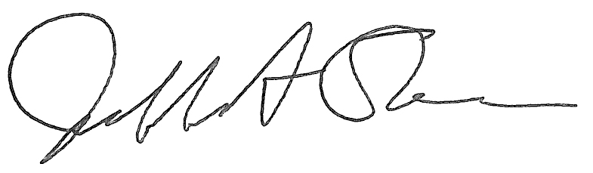
Jeffrey A. Stein
Secretary, Board of Trustees

c. Members of the Board of Trustees
President Killeen
Mr. Engle
University Officers
Members of the Press

Meeting of the University Healthcare System Committee
of the Board of Trustees of the University of Illinois

University of Illinois Springfield
Student Union Ballroom, Room 224,
2251 Richard Wright Drive, Springfield, Illinois

The University Healthcare System Committee Meeting will be webcast live at the following address:
https://www.uis.edu/uislive

Please be advised that the times for various parts of the meeting are estimates and that the order of business may be adjusted as the meeting progresses.

Wednesday, March 18, 2026
12:30 p.m. Meeting of the Committee Convenes
- Roll Call

12:35 p.m. Executive Session

1:00 p.m. Meeting Reconvenes
- Opening Remarks by the Chair of the Committee
- Action Item- Approval of Minutes of Meeting of January 14, 2026
- Opening Remarks by Dr. Robert Barish, vice chancellor for health affairs, Chicago

1:10 p.m. Review Recommended Board Items for March 19, 2026, Board Meeting
- Approve the University of Illinois 2025 Community Assessment of Needs Report and Implementation Plan, University of Illinois Hospital and Clinics, Chicago
- Approve Revisions to Mission Statement of Graduate Medical Education, University of Illinois College of Medicine and University of Illinois Hospital and Clinics, Chicago

1:15 p.m. Presentations
  - Hospital and Clinics CEO Report
  - Quality Data Report

1:35 p.m. Old Business

New Business
- Next Meeting- May 20, 2026, 12:30 p.m., I Hotel and Conference Center, Illinois Ballroom, 1901 South First Street, Champaign

1:40 p.m. Meeting of the Committee Adjourns When Business is Completed

Written Reports
  - Hospital Dashboard

