UNIVERSITY OF ILLINOIS

Urbana-Champaign • Chicago • Springfield

The Board of Trustees

352 Henry Administration Building, MC-350

506 South Wright Street

Urbana, IL 61801

March 13, 2025

**NOTICE**

On call of the Chair, a meeting of the Audit, Budget, Finance, and Facilities Committee of the Board of Trustees of the University of Illinois will be held on Wednesday, March 19, 2025, beginning at 2:00 p.m., in the Student Union Ballroom, Room 224, 2251 Richard Wright Drive, Springfield, Illinois. (A copy of the schedule/agenda is attached.)

The meeting will also be webcast live at the following address:

https://www.uis.edu/uislive.

The Board of Trustees meetings are open to the public, pursuant to Illinois state law and the Board’s own procedures. Attendees will not be permitted to knowingly interfere with or impede, through disruptions or other means, the Board’s performance of its institutional duties. Individuals who disrupt the meeting will be asked to leave. If the disruption continues following due notice to depart the meeting space, individuals will be removed from the premises. Individuals who disrupt the Board’s performance of its institutional duties or refuse to leave the meeting may be in violation of state laws, including but not limited to the Illinois Interference with a Public Institution of Education Act.

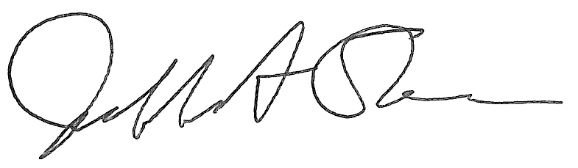

Jeffrey A. Stein Secretary of the Board of Trustees

c: Members of the Board of Trustees

President Killeen

Mr. McKeever

University Officers

Members of the Press

**Meeting of the Audit, Budget, Finance, and Facilities Committee**

**of the Board of Trustees of the University of Illinois**

University of Illinois Springfield

Student Union Ballroom, Room 224,

2251 Richard Wright Drive, Springfield, Illinois

The Audit, Budget, Finance, and Facilities Committee Meeting will be webcast live at the following address:

https://www.uis.edu/uislive

Please be advised that the times for various parts of the meeting are estimates and that the order of business may be adjusted as the meeting progresses.

**Wednesday, March 19, 2025**

2:00 p.m.* **Meeting of the Committee Convenes**

* Roll Call
* Opening Remarks by the Chair of the Committee
* *Action Item*- Approval of Minutes of Meeting of January 22, 2025

2:05 p.m. **Review of Recommended Board Items for March 20, 2025, Board Meeting**

* + - Appoint External Audit Firm for Illinois Quantum and Microelectronics Park, LLC
    - Name Artisan Village Area, Allerton Park and Retreat Center, Urbana
    - Approve Project Budget and Award Construction Contract for Clark, Barton, and Lundgren Halls – Heating Piping Replacement, Urbana
    - Approve Project Budget for Renovation, Altgeld Hall and Replacement, Illini Hall, Urbana
    - Approve Project Budget and Award Construction Contract for Undergraduate Library Redevelopment, Urbana
    - Amend Professional Services Consultant Contract for Cancer Center Research and Health Innovation Complex, Urbana
    - Approve Design and Award Construction Contract for Doris Kelley Christopher Illinois Extension Center, Urbana
      * Doris Kelley Christopher Illinois Extension Center presentation
    - Approve Project Budget and Design, Amend Professional Services Consultant and Construction Manager Contracts for Jefferson Hall and Henry Hall Renovations, Chicago
      * Jefferson and Henry Halls Renovation presentation
    - Delegate Authority to the Comptroller to Initiate a Public-Private Partnership Pre-Development Process and to Enter into Related Agreements to Construct the National Quantum Facility, Chicago
    - Purchase Recommendations

2:55 p.m. **Presentation**

* Summary of Internal Audit Activity Through Second Quarter Ended December 31, 2024

3:05 p.m. **Old Business**

**New Business**

* + Next Meeting- May 21, 2025, 1:15 p.m., I Hotel and Conference Center, Heritage Hall, 1901 South First Street, Champaign

3:10 p.m. **Meeting of the Committee Adjourns When Business is Complete**