UNIVERSITY OF ILLINOIS

Urbana-Champaign • Chicago • Springfield

The Board of Trustees

352 Henry Administration Building, MC-350

506 South Wright Street

Urbana, IL 61801

March 13, 2025

**NOTICE**

On call of the Chair, a meeting of the Governance, Personnel, and Ethics Committee of the Board of Trustees of the University of Illinois will be held on Wednesday, March 19, 2025, beginning at 1:15 p.m., in the Student Union Ballroom, Room 224, 2251 Richard Wright Drive, Springfield, Illinois. (A copy of the schedule/agenda is attached.)

The meeting will also be webcast live at the following address:

https://www.uis.edu/uislive.

The Board of Trustees meetings are open to the public, pursuant to Illinois state law and the Board’s own procedures. Attendees will not be permitted to knowingly interfere with or impede, through disruptions or other means, the Board’s performance of its institutional duties. Individuals who disrupt the meeting will be asked to leave. If the disruption continues following due notice to depart the meeting space, individuals will be removed from the premises. Individuals who disrupt the Board’s performance of its institutional duties or refuse to leave the meeting may be in violation of state laws, including but not limited to the Illinois Interference with a Public Institution of Education Act.

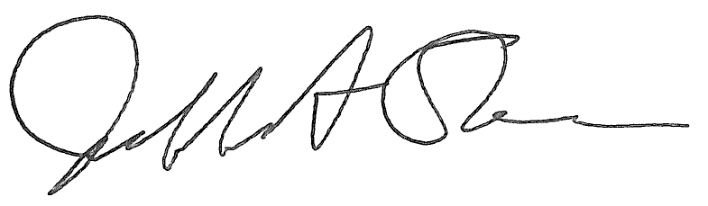

Jeffrey A. Stein

Secretary, Board of Trustees

c. Members of the Board of Trustees  
 President Killeen  
 Mr. McKeever  
 University Officers  
 Members of the Press

**Meeting of the Governance, Personnel, and Ethics Committee**

**of the Board of Trustees of the University of Illinois**

University of Illinois Springfield

Student Union Ballroom, Room 224,

2251 Richard Wright Drive, Springfield, Illinois

The Governance, Personnel, and Ethics Committee Meeting will be webcast live at the following address:

https://www.uis.edu/uislive

Please be advised that the times for various parts of the meeting are estimates and that the order of business may be adjusted as the meeting progresses.

**Wednesday, March 19, 2025**

1:15 p.m. **Meeting of the Committee Convenes**

* Roll Call
* Opening Remarks by the Chair of the Committee
* *Action Item*- Approval of Minutes of Meeting of January 22, 2025

1:20 p.m. **Review Recommended Board Items for March 20, 2025, Board Meeting**

* Appointments to the Faculty, Administrative/Professional Staff, and Intercollegiate Athletic Staff
* Approve Minutes of the Board of Trustees as the Sole Member of the Illinois Quantum and Microelectronics Park, LLC meeting
* Amend Operating Agreement of the University of Illinois Research Park, LLC

1:35 p.m. **Presentations**

* GLBA Risk Assessment and Reporting
* University of Illinois System International Strategy
* Legislative Update

1:50 p.m. **Old Business**

**New Business**

* + Next Meeting- May 21, 2025, 12:00 p.m., I Hotel and Conference Center, Heritage Hall, 1901 South First Street, Champaign

1:55 p.m. **Meeting of the Committee Adjourns When Business is Completed**