UNIVERSITY OF ILLINOIS

Urbana-Champaign • Chicago • Springfield

The Board of Trustees

352 Henry Administration Building, MC-350

506 South Wright Street

Urbana, IL 61801

March 21, 2024

**NOTICE**

On call of the Chair, a meeting of the Audit, Budget, Finance, and Facilities Committee of the Board of Trustees of the University of Illinois will be held on Wednesday, March 27, 2024, beginning at 2:15 p.m., in the Student Union Ballroom, Room 224, 2251 Richard Wright Drive, Springfield, Illinois. (A copy of the schedule/agenda is attached.)

The meeting will also be webcast live at the following address:

https://www.uis.edu/uislive.

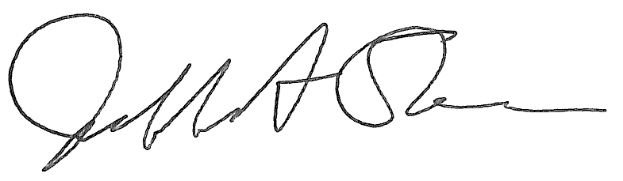

Jeffrey A. Stein Secretary of the Board of Trustees

c: Members of the Board of Trustees

President Killeen

Mr. McKeever

University Officers

Members of the Press

**Meeting of the Audit, Budget, Finance, and Facilities Committee**

**of the Board of Trustees of the University of Illinois**

University of Illinois Springfield

Student Union Ballroom, Room 224,

2251 Richard Wright Drive, Springfield, Illinois

The Audit, Budget, Finance, and Facilities Committee Meeting will be webcast live at the following address:

https://www.uis.edu/uislive

Please be advised that the times for various parts of the meeting are estimates and that the order of business may be adjusted as the meeting progresses.

**Wednesday, March 27, 2024**

2:15 p.m.* **Meeting of the Committee Convenes**

* Roll Call
* Opening Remarks by the Chair of the Committee
* *Action Item*- Approval of Minutes of Meeting of January 17, 2024

2:20 p.m. **Review Recommended Board Items for March 28, 2024, Board Meeting**

* + - Rename the College of Veterinary Medicine South Clinic, Veterinary Teaching Hospital, Urbana
    - Appoint University of Illinois Banker in India for Its Liaison Office in New Delhi, India and Its Branch Office in Bengaluru, India
    - Revise Dollar Limits on Purchases, Leases, Budget Approval, Contract Approval, and Other Actions Requiring Specific Board of Trustees Authorization
    - Delegate Authority to Comptroller to Approve Lease Amendment for Space at 111 East Green Street, Champaign, Illinois
    - Award Construction Contract for Beckman Institute Café Renovation, Urbana
    - Purchase Recommendations

3:00 p.m. **Presentation**

* Summary of Internal Audit Activity Through Second Quarter Ended December 31, 2023

3:10 p.m. **Old Business**

**New Business**

* + Next Meeting- May 15, 2024, 2:15 p.m., I Hotel and Conference Center, Heritage Hall, 1901 South First Street, Champaign

3:15 p.m. **Meeting of the Committee Adjourns When Business is Complete**