UNIVERSITY OF ILLINOIS

Urbana-Champaign • Chicago • Springfield

The Board of Trustees

352 Henry Administration Building, MC-350

506 South Wright Street

Urbana, IL 61801

March 21, 2024

**NOTICE**

On call of the Chair, a meeting of the Academic and Student Affairs Committee of the Board of Trustees of the University of Illinois will be held on Wednesday, March 27, 2024, beginning at 3:20 p.m., in the Student Union Ballroom, Room 224, 2251 Richard Wright Drive, Springfield, Illinois. (A copy of the schedule/agenda is attached.)

The meeting will also be webcast live at the following address: https://www.uis.edu/uislive.

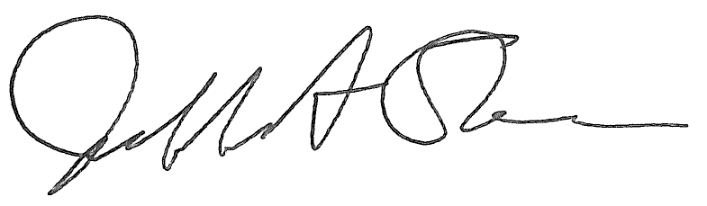

Jeffrey A. Stein Secretary of the Board of Trustees

c: Members of the Board of Trustees

President Killeen

Mr. McKeever

University Officers

Members of the Press

**Meeting of the Academic and Student Affairs Committee**

**of the Board of Trustees of the University of Illinois**

University of Illinois Springfield

Student Union Ballroom, Room 224,

2251 Richard Wright Drive, Springfield, Illinois

The Academic and Student Affairs Committee Meeting will be webcast live at the following address:

https://www.uis.edu/uislive

Please be advised that the times for various parts of the meeting are estimates and that the order of business may be adjusted as the meeting progresses.

**Wednesday, March 27, 2024**

3:20 p.m.* **Meeting of the Committee Convenes**

* Roll Call
* Opening Remarks by the Chair of the Committee
* *Action Item*- Approval of Minutes of Meeting of January 17, 2024

3:25 p.m. **Review Recommended Board Items for March 28, 2024, Board Meeting**

* Appointments to the Faculty, Administrative/Professional Staff, and Intercollegiate Athletic Staff
* Approve Sabbatical Leaves of Absence, 2024-2025
* Approve Student Health Insurance Rates for University of Illinois Urbana-Champaign, Academic Year 2024-2025
* Appoint Interim Vice Chancellor for Diversity, Equity, and Engagement, Chicago
* Appoint Dean, College of Dentistry, Chicago
* Appoint Interim Dean, College of Public Affairs and Education, Springfield
* Rename the Department of English and Modern Languages, College of Liberal Arts and Social Sciences, Springfield
* Appoint Fellows to the Center for Advanced Study, Academic Year 2024-2025, Urbana
* Appoint Associates to the Center for Advanced Study, Academic Year 2024-2025, Urbana
* Establish the Master of Science in Game Development, School of Information Sciences and the Graduate College, Urbana
* Appoint Faculty Fellows to the Institute for the Humanities, Academic Year 2024-2025, College of Liberal Arts and Sciences, Chicago
* Establish the Bachelor of Arts in Liberal Arts and Sciences, Major in Linguistics, College of Liberal Arts and Sciences, Chicago
* Establish the Bill and Julie Kellner Center for Neurogenomics, Behavior, and Society, Carl R. Woese Institute for Genomic Biology, Urbana
* Amend the University of Illinois Urbana-Champaign Senate *Constitution*, Urbana
* Award Honorary Degree, Urbana
* Award Honorary Degree, Springfield

3:55 p.m. **Presentations**

* Research Integrity
* Aspirations for Consilience at UIS

4:20 p.m. **Old Business**

**New Business**

* + Next Meeting- May 15, 2024, 3:30 p.m., I Hotel and Conference Center, Heritage Hall, 1901 South First Street, Champaign

4:25 p.m. **Meeting of the Committee Adjourns When Business is Completed**