# ILLINOIS FREEDOM OF INFORMATION ACT (FOIA) and OFFICE OVERVIEW

The Illinois Freedom of Information Act (FOIA) is a statute that provides the public access to the documents and records of public bodies, including the University of Illinois System (System). FOIA was enacted in 1984 and is modeled from the federal FOIA, which was enacted in 1965. Under this statute, the System is a public body that must respond to most requests within five (5) business days, though an extension may be taken that provides an additional five (5) business days to respond. Within the five- or ten-business-day period, the System coordinates with the appropriate personnel and/or unit(s) to collect responsive records and review them for any applicable exemptions under FOIA. The FOIA Office provides responsive records, subject to any redactions or withholding pursuant to an appropriate exemption, and provides a detailed basis for the exemption. A minimum of 26 exemptions exist in the statute that serve to withhold records on the basis of such things as personal privacy, pending law enforcement investigations, trade secrets, and other statutes.

In 2011, after the statute was subject to several substantial amendments, the process for responding to FOIA requests was centralized so the System Offices could coordinate all three universities (Urbana-Champaign, Chicago, and Springfield) and provide System-wide consistency in complying with FOIA. Presently, the Office of External Relations and Communications (ERC) processes FOIA requests made to all three universities and System Offices. Director of External Relations and Communications Kirsten Ruby and Associate Director for FOIA Administration Matt Sullard coordinate this centralized process, manage the distributed FOIA processing staff in conjunction with University of Illinois Chicago Strategic Marketing and Communications and University of Illinois Urbana-Champaign Strategic Communications and Marketing personnel, and serve as liaison to requestors and to the Illinois Attorney General’s Public Access Bureau. On complex and sensitive FOIA matters, FOIA staff consult with the Office of University Counsel and finalize all response letters. Matt Sullard and the FOIA team work with communications and administrative staff throughout the system to ensure proper and timely sharing of information.

As this report shows, the number of requests annually continued its upward trend. The System received 1,226 requests in 2022 and is currently projected to received approximately 1,800 in 2023. In 2022 FOIA professionals successfully handled the increased workload, while also overcoming the challenges of complex SHIELD-related requests, increasing numbers of recurrent requestors, and personnel changes – including the Associate Director – resulting in the office functioning with one vacant position for nearly half of the year.

FOIA requests continue to become more complex and time-consuming. The largest contributing factor may be the increases in requests for communications and/or correspondence, including email communications. These requests tend to require more scrutiny due to the nature of correspondence. For example, a request seeking email communications from faculty may be very likely to include communications among or regarding students and their academics. These communications need to be scrutinized line-by-line to appropriately apply exemptions to protect private or personal information, or student-related information protected under the Federal Educational Rights and Privacy Act (FERPA). The chart below tracks the trend of requests seeking correspondence and/or communications, largely those conducted via email. In 2016, 61 such requests were logged. In 2022, that number was 143. In the first two-and-a-half months of 2023, that number is 105.

Reported to the Board of Trustees

March 30, 2023

Another common example may be multiple individuals using email to coordinate on a draft of a release or project. Under the exemption known as the “deliberative process exemption,” pre-decisional or deliberative communications are exempt from production. This supports a public policy encouraging frank and open discussion in crafting final determinations, especially regarding policies or decisions with a wide impact. When topics in the pre-decisional stage are included in a request for records, the FOIA Office must scrutinize the communications for the appropriate redacting, which often requires back-and-forth collaboration with the provider(s) of the communications to ensure the exemption is being applied to pre-decisional items accurately.

Other sensitive topics included in requests for correspondence and/or communications may include delicate or technical IT information, medical information or data, including SHIELD Illinois and SHIELD T3, and protected attorney-client communications.

Multiple-part requests and requests seeking records from multiple System universities also add to the complexity of a request, as each such request functions as several-in-one. These requests often require additional coordination among various personnel and/or units.

Further, requestors receiving responses denying a request in whole or in part pursuant to an appropriate exemption, or receiving responses that a request is unduly burdensome to the System (with an opportunity to narrow the request provided) often return with one more follow-up requests. These requestors can quickly find themselves considered recurrent requestors under FOIA. For example, one such requestor seeking records from the University of Illinois Urbana-Champaign has submitted 49 requests beginning December 5, 2022. Due to the broad nature and volume of these requests, this individual has become a recurrent requestor with 32 open requests.

The increasing knowledge, accessibility, and ease of submitting a FOIA request has likely contributed to the increases in volume. Technological advancements have created the possibility of submitting requests simply via one’s smartphone throughout the day, or during evenings or weekends. The System’s well-earned high profile and numerous contributions to the State of Illinois puts it frequently in the public eye, which keeps the System in the minds of those seeking information.

The FOIA team and assignments are listed below:

* + Matt Sullard – assignments, approvals, overflow, complex, and recurrent requests
  + Jill Weathers – Multi-campus, Springfield, and System Offices requests
  + Jaclyn Banister – Urbana requests
  + Jenny Fontaine – Chicago requests
  + Heather Toth – Urbana Division of Intercollegiate Athletics and commercial System requests

Kirsten Ruby is the signatory of response letters as Chief Records Officer for the System. Several of the team members listed above provide services to the FOIA Office on a part-time basis, either as part-time employees or with divided duties. Generally, one absence creates a void of roughly 20% of the FOIA team’s workforce.

**BY THE NUMBERS**

* In calendar year 2022, the U of I System received 1,226 requests resulting in the review of over 150,000 pages of records. This represents 83 more requests – or 7.3% – and more than 30,000 additional pages to review than in 2021. Requests received in 2022 totaled more than 100 in six separate months with another four months reaching in excess of 90 requests.

**Received in Calendar 2022**

|  |  |  |  |
| --- | --- | --- | --- |
| **Month** | **Received** | **Closed** | **Pages Reviewed** |
| January | 100 | 44 | 5,401 |
| February | 126 | 88 | 14,752 |
| March | 143 | 126 | 13,935 |
| April | 97 | 103 | 9,032 |
| May | 96 | 87 | 7,720 |
| June | 77 | 77 | 18,636 |
| July | 103 | 81 | 10,914 |
| August | 101 | 90 | 6,452 |
| September | 82 | 72 | 8,068 |
| October | 110 | 101 | 8,325 |
| November | 98 | 85 | 9,607 |
| December | 93 | 94 | 37,295 |
|  |  |  |  |
| Total | 1,226 | 1,048 | 150,137 |
|  |  |  |  |
| Average | 102.17 | 87.33 | 12,511.42 |

* The term “closed” means (1) our office issued a final response approving or denying the request; (2) our office issued a request to narrow letter, to which the requestor did not respond; or (3) the request was withdrawn.

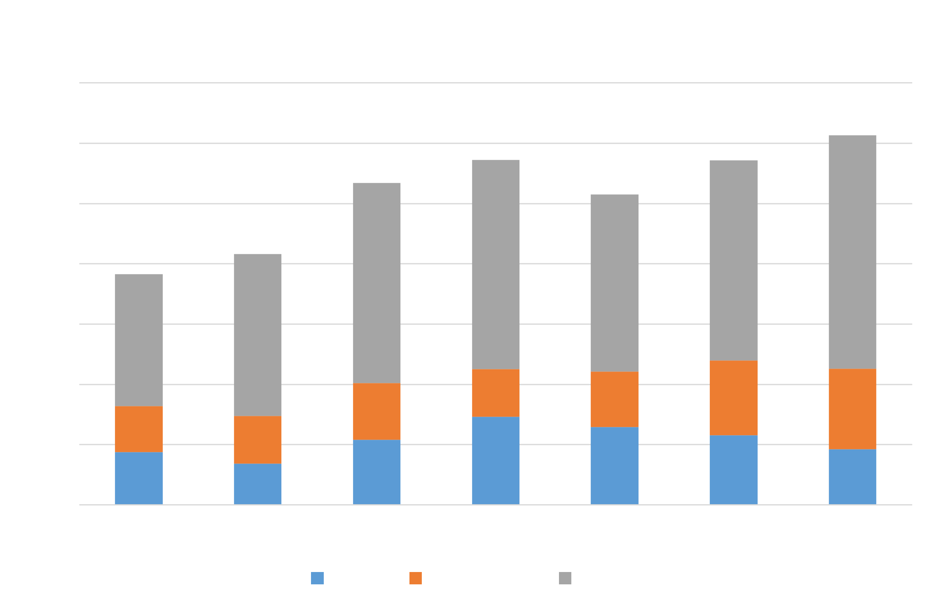

* In calendar year 2022, total requests continued its upward trend. While the University of Illinois Urbana-Champaign continued to receive the most requests by far, its total was actually 39 fewer than 2021.

**Campus of Interest Statistics**

|  |  |  |  |  |
| --- | --- | --- | --- | --- |
| **Campus** | **2021 Requests** | **2022 Requests** | **2022 Percentage of Requests** | **2022 Pages Provided** |
| Urbana-Champaign | 705 | 666 | 54.32% | 62,504 |
| Chicago | 249 | 279 | 22.76% | 48,315 |
| Springfield | 89 | 80 | 6.53% | 3,563 |
| System | 70 | 145 | 11.83% | 5,691 |
| Multiple universities | 30 | 56 | 4.56% | 30,064 |

**2022 Requests by Campus**

|  |  |  |  |  |  |  |
| --- | --- | --- | --- | --- | --- | --- |
|  | **Total** | **Urbana** | **Chicago** | **Springfield** | **System** | **Multi** |
| Number of Media | 185 | 117 | 26 | 5 | 24 | 13 |
| Number of Commercial | 267 | 106 | 96 | 14 | 37 | 14 |
| Number of Private/Other | 774 | 443 | 158 | 61 | 86 | 29 |
| Total | 1,226 | 666 | 279 | 80 | 145 | 56 |
|  |  |  |  |  |  |  |
| Percent of Media requests by campus |  | 63.24% | 14.05% | 2.70% | 12.97% | 7.03% |
| Percent of Commercial requests by campus |  | 39.70% | 35.96% | 5.24% | 13.86% | 5.24% |
| Percent of Private/Other requests by campus |  | 57.24% | 20.41% | 7.88% | 11.11% | 3.75% |

|  |  |
| --- | --- |
| Overall percent of Media requests | 15.09% |
| Overall percent of Commercial requests | 21.78% |
| Overall percent of Private/Other requests | 63.13% |

* Of note, the number of System-level requests, which includes SHIELD Illinois and SHIELD T3, more than doubled from last year’s total of 70. A total of 88 SHIELD- or COVID-related requests were submitted in 2022. For comparison, records indicate 2020 yielded 113 SHIELD- or COVID-related requests, and while 54 such requests were received in 2021. Of those submitted in 2022, 65 were received in the first four (4) months of the year. Each of the remaining months had no more than five (5), with an exception noted for August with 11 such requests. Of note, the System disseminated information regarding COVID requirements for the Fall Semester around that time.
* **2022 REQUESTS SOUGHT:**
  + SHIELD Illinois
  + Vendor agreements & Purchasing orders
  + NCAA expense reports
  + Grade distributions
  + Police reports
  + Bid information
  + Athletic contracts
  + Emails
  + Admissions Data
  + Disciplinary records
  + Course syllabi
  + Water well records
  + Salary information
  + Settlement agreements
  + Student directory information
  + Title IX Information
  + Sexual misconduct reports
  + Uncashed checks
  + Investment information
* In 2022, the U of I System received roughly 85 requests related to the COVID-19 pandemic, up from roughly 60 such requests in 2021. Those requests were for:
  + SHIELD Illinois high school COVID test information
  + SHIELD Illinois reports
  + SHIELD Illinois payment information
  + SHIELD Illinois transaction history & financial ledgers
  + SHIELD Illinois RFP information
  + SHIELD T3 research participation
  + Inmate COVID data
  + COVID testing policies
  + COVID studies & reports
  + COVID email communications
  + COVID relief fund records
  + SHIELD Illinois and SHIELD T3 (PowerPoint) presentations
  + SHIELD Illinois and SHIELD T3 contracts
  + SHIELD Illinois and SHIELD T3 email communications
  + SHIELD Illinois and SHIELD T3 inventory information
  + SHIELD Illinois and SHIELD T3 invoices
  + SHIELD Illinois and SHIELD T3 vendor payments
  + SHIELD Illinois and SHIELD T3 Emergency Use Authorization records
* **2022 COMMON EXEMPTIONS APPLIED:**
  + Section 7(1)(a) – information prohibited by disclosure from a federal or state statute such as the Federal Education Rights and Privacy Act (FERPA), the Personnel Records Review Act (PRRA), and the Health Insurance Portability and Accountability Act (HIPAA).
  + Section 7(1)(b) – private information. This includes individually-identifiable information that could lead to identity theft, such as home addresses, personal telephone numbers, and social security numbers.
  + Section 7(1)(c) – personal information. This includes highly personal information such as dates of birth, private citizen names, and race.
  + Section 7(1)(d)(i) – information that would interfere with law enforcement proceedings.
  + Section 7(1)(d)(iv) - witness information. This includes people who provide information to the University of Illinois Department of Public Safety.
  + Section 7(1)(f) – deliberative communication. This includes pre-decisional opinions in emails, recommendations for a course of action, and draft copies.
  + Section 7(1)(g) – trade secrets. This includes confidential or proprietary information given to the University, usually as part of a bid proposal.
  + Section 7(1)(j)(ii) – student misconduct cases.
  + Section 7(1)(m) – attorney/client information. This includes legal advice by the Office of the University Counsel to University staff.
  + Section 7(1)(n) – disciplinary reports. This includes reports regarding employee misconduct determined unfounded or when discipline was not imposed.
* **2022 TYPES OF REQUESTORS:**
  + News media
  + Current and former students
  + Current and former employees
  + Vendors
  + Data research companies
  + Law firms
  + Other universities
  + Not for profits

**Type of Request Received**

|  |  |  |  |
| --- | --- | --- | --- |
| **Month** | **Media** | **Commercial** | **All Else** |
| January | 28 | 31 | 41 |
| February | 28 | 23 | 75 |
| March | 15 | 37 | 91 |
| April | 17 | 17 | 63 |
| May | 15 | 12 | 69 |
| June | 13 | 17 | 47 |
| July | 14 | 25 | 64 |
| August | 14 | 19 | 68 |
| September | 9 | 25 | 48 |
| October | 14 | 24 | 72 |
| November | 8 | 17 | 73 |
| December | 10 | 20 | 63 |
|  |  |  |  |
| Total | 185 | 267 | 774 |
|  |  |  |  |
| Average | 15.42 | 22.25 | 64.5 |

* Several 2022 requests were related to matters that were of significant media interest, such as:
  + NCAA Financial Reports
  + Athletics coach and game contracts
  + Concert tour riders
  + Title IX investigations
  + SHIELD Illinois and Shield T3 information and communications

**2022 MEDIA REQUESTORS:**

* + Arnolt Center of Investigative Journalism
  + Associated Press
  + The Athletic
  + Bloomberg News
  + Boardroom.tv
  + Bracketeer.org
  + CAA
  + Capital News Service (Maryland)
  + Capitol News Illinois
  + Check CU (Champaign-Urbana, IL)
  + Chicago Sun-Times
  + Cleveland.com
  + The College Fix
  + College Gym News
  + The Courier-Journal (Louisville, KY)
  + Crain’s Chicago Business
  + CU-CitizenAccess (Champaign-Urbana, IL)
  + The D1 Docket
  + The Daily Dot
  + The Daily Egyptian (Southern Illinois University)
  + The Daily Illini
  + Defector Media (sports and culture)
  + Edgar County Watchdogs
  + ESPN
  + Extra Points / D1.ticker
  + The Forward (American Jewish news)
  + Freelance / Independent / Unknown media
  + Grist.org (Nonprofit climate news)
  + Illini Media
  + Injustice Watch
  + Investigate TV
  + Invisible Institute
  + Mlive
  + Naperville Central Times
  + National Association of Scholars
  + NBC5 Chicago
  + NCAA.com
  + The News-Gazette (Champaign, IL)
  + NJ Advance Media
  + On3.com
  + ProPublica
  + The Record / USA Today
  + Runnin’ Hoops Podcast
  + Shaw Media
  + The Southern Illinoisan
  + Sportico
  + Springfield Leaks
  + St. Louis Business Journal
  + St. Louis Post-Dispatch
  + State Journal-Register
  + Substance News
  + Syracuse University / USA Today
  + UIS Observer
  + USA Today
  + The Wall Street Journal
  + WCIA (Champaign, IL)
  + WILL (NPR affiliate)
  + WNIJ Northern Public Radio (DeKalb, IL)

**Requests by Media Outlet**

57 total outlets.   
*Other* includes outlets filing fewer than 10 requests.

**2022 HIGHLIGHTS and QUICK FACTS**

* Any requestor may ask for a request for review of the System’s response with the Office of the Attorney General’s Public Access Counselor (PAC) or file a lawsuit pursuant to Section 11 of FOIA. A request for review is not an indicator of any impropriety or improper handling of a request or responsive documents, but simply asks the PAC to review the public body’s response to ensure good-faith application of FOIA. When these appeals occur, the System is afforded an opportunity to provide supporting argument and/or evidence for its response and defend its handling of a request.

Of the 1,226 requests submitted to the System in 2022, System responses were appealed to PAC 21 times. This represents less than two percent (2%) of U of I System responses in 2022. Of those 21 appeals:

* Nine (9) are still pending
* Six (6) received a determination of No Further Action Warranted
* Two (2) received a determination of Unfounded (meaning the requestor’s complaint was unfounded)
* Two (2) received a determination of No Violation
* One (1) received a determination that the System did not meet its burden to successfully claim the records were exempt. This was a matter of first impression for the System, regarding Automatic License Plate Readers (ALPRs) on the Urbana-Champaign campus. The requestor sought the locations of all ALPRs under University control, as well as photos demonstrating their points-of-view. After discussing the best approach with the University of Illinois Police Department and the Office of University Counsel, the System withheld these items pursuant to Sections 7(1)(d)(v) and 7(1)(v) of FOIA as unique or special investigative techniques and security measures. The PAC determined that exemption 7(1)(v) is largely meant to exempt records related to homeland security and emergency preparations. That, plus the ALPRs’ placement in public locations which makes them visible to the naked eye, prevents usage of the exemptions. The System was directed to provide the requested records, subject to any other applicable exemption(s).
* One (1) received a determination that System was barred from claiming the request was unduly burdensome, due to a typographical error in the email address delaying the System’s response past the required deadline. Because the ability to utilize the categorization of a request as unduly burdensome requires strict adherence to statutory deadlines, the System was prohibited from using the designation, and was directed to produce the requested records.
* In 2022, the FOIA Office continued to update its website with the latest information, including select FOIA response letters dating back to 2015.
* The FOIA Office provided training presentations for various colleges and departments within the U of I System. In calendar year 2022, the FOIA Office presented to:
  + SHIELD T3
  + Urbana-Champaign College of Liberal Arts & Sciences
  + Discovery Partners Institute
  + University Senates Conference
  + Records and Information Management Services (RIMS) Advisory Committee
  + Certified Business Administrator Group
* As is our customary practice, Director of External Relations and Communications Kirsten Ruby, Associate Director for FOIA Administration Matt Sullard, and the FOIA coordinators completed the yearly FOIA training required by the Office of the Illinois Attorney General.
* Throughout the year, FOIA staff met weekly (over Zoom) to discuss issues, processing policies, and new developments with the law.
* The FOIA Office held an in-person retreat to discuss various topics and produce best practices and policies. Scott Rice and Andrea Schneider from the Office of University Counsel, as well as Vice President for External Relations and Communications Adrienne Nazon, were able to join the FOIA team for this discussion.
* The FOIA staff had planned to hold FOIA retreat in June 2020 for FOIA officers at other Illinois higher education institutions. This was canceled due to the COVID-19 pandemic. The retreat will be re-scheduled and feature panel presentations and discussions from University of Illinois System officers and representatives from the Illinois Attorney General Public Access Counselor’s office.