UNIVERSITY OF ILLINOIS

Urbana-Champaign • Chicago • Springfield

The Board of Trustees

352 Henry Administration Building, MC-350

506 South Wright Street

Urbana, IL 61801

May 9, 2024

**NOTICE**

On call of the Chair, a meeting of the Audit, Budget, Finance, and Facilities Committee of the Board of Trustees of the University of Illinois will be held on Wednesday, May 15, 2024, beginning at 2:15 p.m., in the I Hotel and Conference Center[1], Heritage Hall 1901 South First Street, Champaign, Illinois. (A copy of the schedule/agenda is attached.)

The meeting will also be webcast live at the following address:

https://www.uis.edu/uislive.

The Board of Trustees meeting is open to the public, pursuant to Illinois state law and the Board’s own procedures. Attendees will not be permitted to knowingly interfere with or impede, through disruptions or other means, the Board’s performance of its institutional duties. Individuals who disrupt the meeting will be asked to leave. If the disruption continues following due notice to depart the meeting space, individuals will be removed from the premises. Individuals who disrupt the Board’s performance of its institutional duties or refuse to leave the meeting may be in violation of state laws, including but not limited to the Illinois Interference with a Public Institution of Education Act.

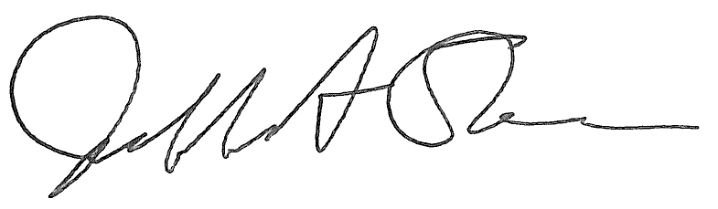

Jeffrey A. Stein Secretary of the Board of Trustees

c: Members of the Board of Trustees

President Killeen

Mr. McKeever

University Officers

Members of the Press

**Meeting of the Audit, Budget, Finance, and Facilities Committee**

**of the Board of Trustees of the University of Illinois**

University of Illinois Urbana-Champaign

I Hotel and Conference Center, Heritage Hall

1901 South First Street, Champaign, Illinois

The Audit, Budget, Finance, and Facilities Committee Meeting will be webcast live at the following address:

https://www.uis.edu/uislive

Please be advised that the times for various parts of the meeting are estimates and that the order of business may be adjusted as the meeting progresses.

**Wednesday, May 15, 2024**

2:15 p.m.* **Meeting of the Committee Convenes**

* Roll Call
* Opening Remarks by the Chair of the Committee
* *Action Item*- Approval of Minutes of Meeting of March 27, 2024
* Opening Remarks from Dr. Paul Ellinger, vice president/chief financial officer and comptroller, University of Illinois System

2:20 p.m. **Review Recommended Board Items for May 16, 2024, Board Meeting**

* + - Approve Preliminary Operating Budget for the Fiscal Year 2025
    - Approve Professional Services Consultant Contract for UI Health Master Facilities Plan, Chicago
    - Approve Project for College of Medicine East Tower Façade Repairs, Chicago (Capital Development Board Project)
    - Approve Project and Design for Renovate Taft Hall, Chicago
      * Taft Hall Renovation Design Presentation
    - Approve Project and Employ Architect/Engineer for Science and Engineering South Façade Repairs, Chicago (Capital Development Board Project)
    - Approve Professional Services Consultant Contract for Replace West Side Back-up Generators, Chicago
    - Authorize the Comptroller to Take Necessary Actions to Sign and File Certain Tax Documents with the Government of India
    - Purchase Recommendations

2:45 p.m. **Presentations**

* FY23 External Audit Findings
* Update on Diversity Vendor and Contract Initiatives
* Summary of Internal Audit Activity Through Third Quarter Ended March 31, 2024

3:10 p.m. **Old Business**

**New Business**

* + Next Meeting- July 10, 2024, 2:15 p.m., Isadore and Sadie Dorin Forum, Rooms D, E, and F, 725 West Roosevelt Road, Chicago

3:15 p.m. **Executive Session**

3:20 p.m. **Meeting of the Committee Reconvenes**

* + *Action Item*- Disclose Certain Minutes of Executive Session Pursuant to the Open Meetings Act

3:25 p.m. **Meeting of the Committee Adjourns When Business is Complete**

1. Per hotel management, the I-Hotel and Conference Center does not permit signs inside the facility. All bags will be subject to inspection.