UNIVERSITY OF ILLINOIS

Urbana-Champaign • Chicago • Springfield

The Board of Trustees

352 Henry Administration Building, MC-350

506 South Wright Street

Urbana, IL 61801

May 9, 2024

**NOTICE**

On call of the Chair, a meeting of the Academic and Student Affairs Committee of the Board of Trustees of the University of Illinois will be held on Wednesday, May 15, 2024, beginning at 3:30 p.m., in the I Hotel and Conference Center[1], Heritage Hall 1901 South First Street, Champaign, Illinois. (A copy of the schedule/agenda is attached.)

The meeting will also be webcast live at the following address: https://www.uis.edu/uislive.

The Board of Trustees meeting is open to the public, pursuant to Illinois state law and the Board’s own procedures. Attendees will not be permitted to knowingly interfere with or impede, through disruptions or other means, the Board’s performance of its institutional duties. Individuals who disrupt the meeting will be asked to leave. If the disruption continues following due notice to depart the meeting space, individuals will be removed from the premises. Individuals who disrupt the Board’s performance of its institutional duties or refuse to leave the meeting may be in violation of state laws, including but not limited to the Illinois Interference with a Public Institution of Education Act.

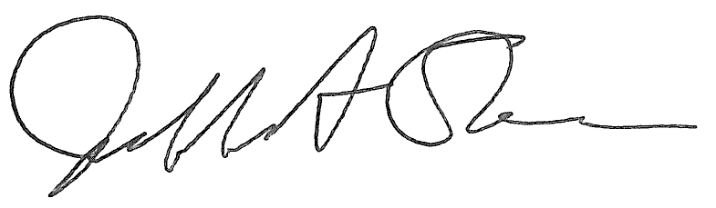

Jeffrey A. Stein Secretary of the Board of Trustees

c: Members of the Board of Trustees

President Killeen

Mr. McKeever

University Officers

Members of the Press

**Meeting of the Academic and Student Affairs Committee**

**of the Board of Trustees of the University of Illinois**

University of Illinois Urbana-Champaign

I Hotel and Conference Center, Heritage Hall

1901 South First Street, Champaign, Illinois

The Academic and Student Affairs Committee Meeting will be webcast live at the following address:

https://www.uis.edu/uislive

Please be advised that the times for various parts of the meeting are estimates and that the order of business may be adjusted as the meeting progresses.

**Wednesday, May 15, 2024**

3:30 p.m.* **Meeting of the Committee Convenes**

* Roll Call
* Opening Remarks by the Chair of the Committee
* *Action Item*- Approval of Minutes of Meeting of March 27, 2024

3:35 p.m. **Review Recommended Board Items for May 16, 2024, Board Meeting**

* Appointments to the Faculty, Administrative/Professional Staff, and Intercollegiate Athletic Staff
* Establish the Siebel School of Computing and Data Science, The Grainger College of Engineering, Urbana
* Eliminate the Master of Science in Special Education, College of Education and the Graduate College, Urbana
* Rename and Revise the Master of Science in Biology, College of Liberal Arts and Sciences and the Graduate College, Urbana
* Rename and Revise the Doctor of Philosophy in Biology, College of Liberal Arts and Sciences and the Graduate College, Urbana
* Appoint Dean, Graduate College, Chicago
* Establish the Doctor of Philosophy in Statistics, College of Liberal Arts and Sciences and the Graduate College, Chicago
* Rename and Revise the Master of Science in Disability and Human Development, College of Applied Health Sciences and the Graduate College, Chicago

3:55 p.m. **Presentations**

* Getting to Know the University of Illinois Press
* Urban Public Space: The Case of Urban Nightlife

4:20 p.m. **Old Business**

**New Business**

* + Next Meeting- July 10, 2024, 3:30 p.m., Isadore and Sadie Dorin Forum, Rooms D, E, and F, 725 West Roosevelt Road, Chicago

4:25 p.m. **Meeting of the Committee Adjourns When Business is Completed**

1. Per hotel management, the I-Hotel and Conference Center does not permit signs inside the facility. All bags will be subject to inspection.