UNIVERSITY OF ILLINOIS
Urbana-Champaign • Chicago • Springfield

The Board of Trustees
352 Henry Administration Building, MC-350
506 South Wright Street
Urbana, IL 61801

May 11, 2023

NOTICE

On call of the Chair, a meeting of the Audit, Budget, Finance, and Facilities Committee of the Board of Trustees of the University of Illinois will be held on Wednesday, May 17, 2023, beginning at 2:15 p.m., in the I Hotel and Conference Center, Heritage Hall, 1901 South First Street, Champaign, Illinois. (A copy of the schedule/agenda is attached.)

The meeting will also be webcast live at the following address:
https://www.uis.edu/uislive.

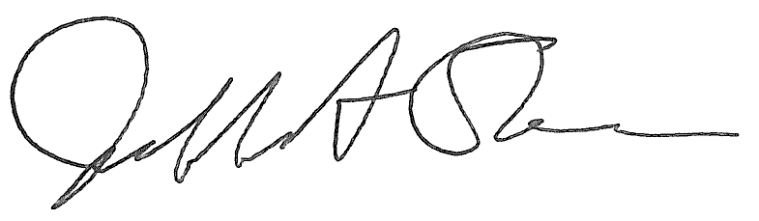
Jeffrey A. Stein Secretary of the Board of Trustees

c: Members of the Board of Trustees
President Killeen
Mr. McKeever
University Officers
Members of the Press

Meeting of the Audit, Budget, Finance, and Facilities Committee
of the Board of Trustees of the University of Illinois

University of Illinois Urbana-Champaign
I Hotel and Conference Center, Heritage Hall
1901 South First Street, Champaign, Illinois

The Audit, Budget, Finance, and Facilities Committee Meeting will be webcast live at the following address:
https://www.uis.edu/uislive

Please be advised that the times for various parts of the meeting are estimates and that the order of business may be adjusted as the meeting progresses.

Wednesday, May 17, 2023
2:15 p.m.* Meeting of the Committee Convenes
- Roll Call
- Opening Remarks by the Chair of the Committee
- Opening Remarks by Dr. Paul Ellinger, vice president, chief financial officer and comptroller
- Action Item- Approval of Minutes of Meeting of March 29, 2023

2:20 p.m. Review Recommended Board Items for May 18, 2023, Board Meeting
- Rename the Undergraduate Library, Urbana
- Approve Preliminary Operating Budget for Fiscal Year 2024
- Delegate Authority to the Vice President/Chief Financial Officer and Comptroller to Refund Outstanding Health Services Facilities System Revenue Bonds
    - Capital and Real Estate Items
      - Approve Project Budget for Small Animal Clinic Oncology Center Addition, Veterinary Teaching Hospital, Urbana
      - Approve Design for Doris Kelley Christopher Illinois Extension Center, Urbana
      - Approve Project Budget and Award Construction Contract for Replace Air Handling Units and Booster Coils, Student Center East, Chicago
      - Approve Professional Services Consultant Contract for Renovate Taft Hall, Chicago
      - Award Construction Contract, Harrison Street Parking Structure Phase 2 Structural Repairs, Chicago
      - Award Construction Contract, School of Public Health and Psychiatric Institute Building Envelope Repair, Chicago
    - Purchase Recommendations

2:40 p.m. Presentations
- Doris Kelley Christopher Illinois Extension Center Design
- Fiscal Year 2022 External Audit Compliance Update
- Summary of Internal Audit Activity through Third Quarter Ended March 31, 2023

3:05 p.m. Old Business

New Business
  - Next Meeting- July 19, 2023, 2:15 p.m., Isadore and Sadie Dorin Forum, Rooms D, E, and F, 725 West Roosevelt Road, Chicago

3:10 p.m. Executive Session

3:15 p.m. Meeting of the Committee Reconvenes
  - Action Item- Disclose Certain Minutes of Executive Sessions Pursuant to the Open Meetings Act

3:25 p.m. Meeting of the Committee Adjourns When Business is Complete

