UNIVERSITY OF ILLINOIS

Urbana-Champaign • Chicago • Springfield

The Board of Trustees

352 Henry Administration Building, MC-350

506 South Wright Street

Urbana, IL 61801

May 11, 2023

**NOTICE**

On call of the Chair, a meeting of the Academic and Student Affairs Committee of the Board of Trustees of the University of Illinois will be held on Wednesday, May 17, 2023, beginning at 3:30 p.m., in the I Hotel and Conference Center, Heritage Hall, 1901 South First Street, Champaign, Illinois. (A copy of the schedule/agenda is attached.)

The meeting will also be webcast live at the following address:

https://www.uis.edu/uislive.

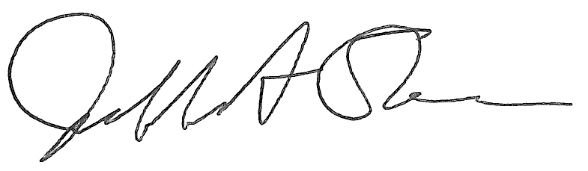

Jeffrey A. Stein Secretary of the Board of Trustees

c: Members of the Board of Trustees

President Killeen

Mr. McKeever

University Officers

Members of the Press

**Meeting of the Academic and Student Affairs Committee**

**of the Board of Trustees of the University of Illinois**

University of Illinois Urbana-Champaign

I Hotel and Conference Center, Heritage Hall

1901 South First Street, Champaign, Illinois

The Academic and Student Affairs Committee Meeting will be webcast live at the following address:

https://www.uis.edu/uislive

Please be advised that the times for various parts of the meeting are estimates and that the order of business may be adjusted as the meeting progresses.

**Wednesday, May 17, 2023**

3:30 p.m.* **Meeting of the Committee Convenes**

* Roll Call
* Opening Remarks by the Chair of the Committee
* *Action Item*- Approval of Minutes of Meeting of March 29, 2023

3:35 p.m. **Review Recommended Board Items for May 18, 2023, Board Meeting**

* Appointments to the Faculty, Administrative/Professional Staff, and Intercollegiate Athletic Staff
* Appoint Interim Chancellor, University of Illinois Chicago, Chicago
* Approve Tuition Rates for Online Master of Science in Architectural Studies, Structures Concentration, Urbana, and Online Master of Public Administration, Chicago
* Appoint Vice Chancellor for Academic Affairs and Provost, Urbana
* Amend the University of Illinois Urbana-Champaign Senate *Constitution*, Urbana
* Appoint Dean, College of Agricultural, Consumer and Environmental Sciences, Urbana
* Rename the Department of Kinesiology and Community Health, College of Applied Health Sciences, Urbana
* Appoint Dean, College of Liberal Arts and Sciences, Chicago
* Establish the Department of Latin American and Latino Studies, College of Liberal Arts and Sciences and Graduate College, Chicago
* Appoint Interim Vice Chancellor for Academic Affairs and Provost, Springfield
* Rename and reorganize the Bachelor of Arts in Global Studies, College of Public Affairs and Education, Springfield

4:25 p.m. **Old Business**

**New Business**

* + Next Meeting- July 19, 2023, 3:30 p.m., Isadore and Sadie Dorin Forum, Rooms D, E, and F, 725 West Roosevelt Road, Chicago

4:30 p.m. **Meeting of the Committee Adjourns When Business is Completed**