UNIVERSITY OF ILLINOIS

Urbana-Champaign • Chicago • Springfield

The Board of Trustees

352 Henry Administration Building, MC-350

506 South Wright Street

Urbana, IL 61801

November 8, 2024

**NOTICE**

On call of the Chair, a meeting of the Audit, Budget, Finance, and Facilities Committee of the Board of Trustees of the University of Illinois will be held on Wednesday, November 13, 2024, beginning at 2:15 p.m., in the Isadore and Sadie Dorin Forum[1], Rooms D, E, and F, 725 West Roosevelt Road, Chicago, Illinois. (A copy of the schedule/agenda is attached.)

The meeting will also be webcast live at the following address:

https://www.uis.edu/uislive.

The Board of Trustees meetings are open to the public, pursuant to Illinois state law and the Board’s own procedures. Attendees will not be permitted to knowingly interfere with or impede, through disruptions or other means, the Board’s performance of its institutional duties. Individuals who disrupt the meeting will be asked to leave. If the disruption continues following due notice to depart the meeting space, individuals will be removed from the premises. Individuals who disrupt the Board’s performance of its institutional duties or refuse to leave the meeting may be in violation of state laws, including but not limited to the Illinois Interference with a Public Institution of Education Act.

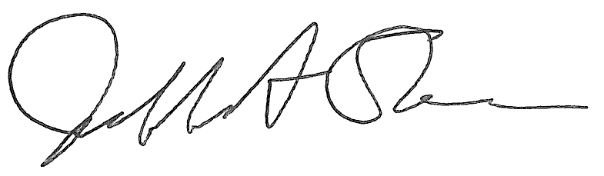

Jeffrey A. Stein Secretary of the Board of Trustees

c: Members of the Board of Trustees

President Killeen

Mr. McKeever

University Officers

Members of the Press

**Meeting of the Audit, Budget, Finance, and Facilities Committee**

**of the Board of Trustees of the University of Illinois**

University of Illinois Chicago

Isadore and Sadie Dorin Forum, Rooms D, E, and F

725 West Roosevelt Road, Chicago, Illinois

The Audit, Budget, Finance, and Facilities Committee Meeting will be webcast live at the following address:

https://www.uis.edu/uislive

Please be advised that the times for various parts of the meeting are estimates and that the order of business may be adjusted as the meeting progresses.

**Wednesday, November 13, 2024**

2:15 p.m.* **Meeting of the Committee Convenes**

* Roll Call
* Opening Remarks by the Chair of the Committee
* *Action Item*- Approval of Minutes of Meeting of September 18, 2024

2:20 p.m. **Presentation**

* + - Fiscal Year 2024 Preliminary Financial Results

2:30 p.m. **Review of Recommended Board Items for November 14, 2024, Board Meeting**

* + - Approve Requests for Operating and Capital Appropriations, Fiscal Year 2026
    - Approve Signature Authority Policy for Illinois Quantum and Microelectronics Park, LLC
    - Revise Dollar Limits on Purchases, Leases, Budget Approval, Contract Approval, and Other Actions Requiring Specific Board of Trustees Authorization
    - Delegate Authority to the Comptroller to Approve Lease Extension for Illini Center in Chicago for the University of Illinois Urbana-Champaign and System
    - Approve Project Budget and Award Construction Contract for Housing Food Stores, Renovate Refrigeration System, Urbana
    - Approve Professional Services Award, College of ACES Buildings, Urbana
    - Approve Project and Amend Professional Services Consultant Contract for Clark, Barton, and Lundgren Halls – Heating Piping Replacement, Urbana
    - Award Construction Contract for Renovate Taft Hall, Chicago
    - Approve Design and Delegate Authority to the Comptroller to Execute the Development, Construction, and Financing of the Grenshaw Street Parking Structure and Taylor-Wood Street Improvements, Chicago
      * Grenshaw Street Parking Structure Design
    - Purchase Recommendations
    - Purchase Recommendations Related to Illinois Quantum and Microelectronics Park, LLC

3:00 p.m. **Presentation**

* Summary of Internal Audit Activity Through First Quarter Ended September 30, 2024

3:10 p.m. **Old Business**

**New Business**

* + Next Meeting- January 22, 2025, 2:15 p.m., Isadore and Sadie Dorin Forum, Rooms D, E, and F, 725 West Roosevelt Road, Chicago

3:15 p.m. **Executive Session**

3:20 p.m. **Meeting of the Committee Reconvenes**

* + *Action Item*- Disclose Certain Minutes of Executive Session Pursuant to the Open Meetings Act

3:25 p.m. **Meeting of the Committee Adjourns When Business is Complete**

1. The UIC Dorin Forum does not permit graphic boards or posters inside the facility. All bags will be subject to inspection.