UNIVERSITY OF ILLINOIS

Urbana-Champaign • Chicago • Springfield

The Board of Trustees

352 Henry Administration Building, MC-350

506 South Wright Street

Urbana, IL 61801

November 8, 2024

**NOTICE**

On call of the Chair, a meeting of the Governance, Personnel, and Ethics Committee of the Board of Trustees of the University of Illinois will be held on Wednesday, November 13, 2024, beginning at 1:30 p.m., in the Isadore and Sadie Dorin Forum[1], Rooms D, E, and F, 725 West Roosevelt Road, Chicago, Illinois. (A copy of the schedule/agenda is attached.)

The meeting will also be webcast live at the following address:

https://www.uis.edu/uislive.

The Board of Trustees meetings are open to the public, pursuant to Illinois state law and the Board’s own procedures. Attendees will not be permitted to knowingly interfere with or impede, through disruptions or other means, the Board’s performance of its institutional duties. Individuals who disrupt the meeting will be asked to leave. If the disruption continues following due notice to depart the meeting space, individuals will be removed from the premises. Individuals who disrupt the Board’s performance of its institutional duties or refuse to leave the meeting may be in violation of state laws, including but not limited to the Illinois Interference with a Public Institution of Education Act.

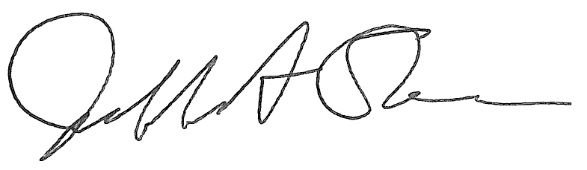

Jeffrey A. Stein

Secretary, Board of Trustees

c. Members of the Board of Trustees  
 President Killeen  
 Mr. McKeever  
 University Officers  
 Members of the Press

**Meeting of the Governance, Personnel, and Ethics Committee**

**of the Board of Trustees of the University of Illinois**

University of Illinois Chicago

Isadore and Sadie Dorin Forum, Rooms D, E, and F

725 West Roosevelt Road, Chicago, Illinois

The Governance, Personnel, and Ethics Committee Meeting will be webcast live at the following address:

https://www.uis.edu/uislive

Please be advised that the times for various parts of the meeting are estimates and that the order of business may be adjusted as the meeting progresses.

**Wednesday, November 13, 2024**

1:30 p.m. **Meeting of the Committee Convenes**

* Roll Call
* Opening Remarks by the Chair of the Committee
* *Action Item*- Approval of Minutes of Meeting of September 18, 2024

1:35 p.m. **Review Recommended Board Items for November 14, 2024, Board Meeting**

* Appointments to the Faculty, Administrative/Professional Staff, and Intercollegiate Athletic Staff
* Amend *The General Rules Concerning University Organization and Procedure*
* Approve 403(b) Plan Amendment
* Appoint Member to Board of Managers for Illinois Quantum and Microelectronics Park, LLC
* Approve Minutes of the Board of Trustees as the Sole Member of Prairieland Energy, Inc., Meeting
* Appoint Directors, Prairieland Energy, Inc.
* Appoint Interim Vice Chancellor for Administration and Operations, Urbana
* Amend Multi-Year Contract with Head Coach, Women’s Basketball, Urbana
* Appoint Vice Chancellor for Advancement, Springfield and Senior Vice President, University of Illinois Foundation

1:45 p.m. **Presentation**

* Legislative Update

1:50 p.m. **Old Business**

**New Business**

* + Next Meeting- January 22, 2025, 1:30 p.m., Isadore and Sadie Dorin Forum, Rooms D, E, and F, 725 West Roosevelt Road, Chicago

1:55 p.m. **Executive Session**

2:05 p.m. **Meeting of the Committee Reconvenes**

* + *Action Item*- Disclose Certain Minutes of Executive Session Pursuant to the Open Meetings Act

2:10 p.m. **Meeting of the Committee Adjourns When Business is Completed**

1. The UIC Dorin Forum does not permit graphic boards or posters inside the facility. All bags will be subject to inspection.