UNIVERSITY OF ILLINOIS

Urbana-Champaign • Chicago • Springfield

The Board of Trustees

352 Henry Administration Building, MC-350

506 South Wright Street

Urbana, IL 61801

November 9, 2023

**NOTICE**

On call of the Chair, a meeting of the Academic and Student Affairs Committee of the Board of Trustees of the University of Illinois will be held on Wednesday, November 15, 2023, beginning at 3:30 p.m., in the Isadore and Sadie Dorin Forum, Rooms D, E, and F, 725 West Roosevelt Road, Chicago, Illinois. (A copy of the schedule/agenda is attached.)

The meeting will also be webcast live at the following address: https://www.uis.edu/uislive.

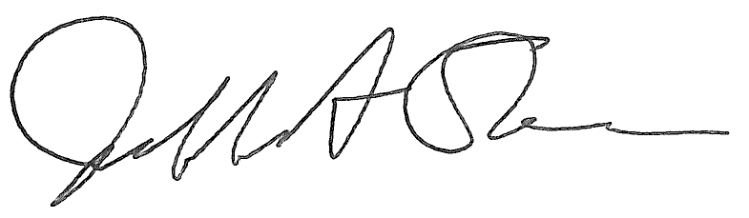

Jeffrey A. Stein Secretary of the Board of Trustees

c: Members of the Board of Trustees

President Killeen

Mr. McKeever

University Officers

Members of the Press

**Meeting of the Academic and Student Affairs Committee**

**of the Board of Trustees of the University of Illinois**

University of Illinois Chicago

Isadore and Sadie Dorin Forum, Rooms D, E, and F

725 West Roosevelt Road, Chicago, Illinois

The Academic and Student Affairs Committee Meeting will be webcast live at the following address:

https://www.uis.edu/uislive

Please be advised that the times for various parts of the meeting are estimates and that the order of business may be adjusted as the meeting progresses.

**Wednesday, November 15, 2023**

3:30 p.m.* **Meeting of the Committee Convenes**

* Roll Call
* Opening Remarks by the Chair of the Committee
* *Action Item*- Approval of Minutes of Meeting of September 20, 2023

3:35 p.m. **Review Recommended Board Items for November 16, 2023, Board Meeting**

* Appointments to the Faculty, Administrative/Professional Staff, and Intercollegiate Athletic Staff

3:40 p.m. **Presentations**

* Accreditation Process
* Quantum Engineering, Chicago
* Transforming Cardiac Arrest Care

4:15 p.m. **Old Business**

**New Business**

* + Next Meeting- January 17, 2024, 3:30 p.m., Isadore and Sadie Dorin Forum, Rooms D, E, and F, 725 West Roosevelt Road, Chicago

4:20 p.m. **Meeting of the Committee Adjourns When Business is Completed**