UNIVERSITY OF ILLINOIS

Urbana-Champaign • Chicago • Springfield

The Board of Trustees

352 Henry Administration Building, MC-350

506 South Wright Street

Urbana, IL 61801

November 9, 2023

**NOTICE**

On call of the Chair, a meeting of the Governance, Personnel, and Ethics Committee of the Board of Trustees of the University of Illinois will be held on Wednesday, November 15, 2023, beginning at 1:30 p.m., in the Isadore and Sadie Dorin Forum, Rooms D, E, and F, 725 West Roosevelt Road, Chicago, Illinois. (A copy of the schedule/agenda is attached.)

The meeting will also be webcast live at the following address:

https://www.uis.edu/uislive.

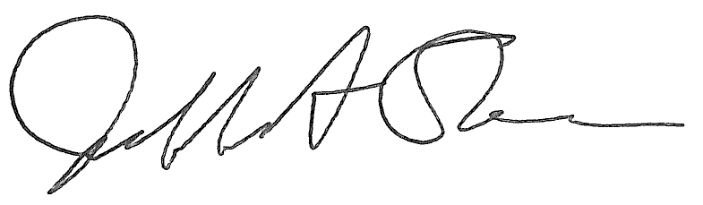

Jeffrey A. Stein

Secretary, Board of Trustees

c. Members of the Board of Trustees  
 President Killeen  
 Mr. McKeever  
 University Officers  
 Members of the Press

**Meeting of the Governance, Personnel, and Ethics Committee**

**of the Board of Trustees of the University of Illinois**

University of Illinois Chicago

Isadore and Sadie Dorin Forum, Rooms D, E, and F

725 West Roosevelt Road, Chicago, Illinois

The Governance, Personnel, and Ethics Committee Meeting will be webcast live at the following address:

https://www.uis.edu/uislive

Please be advised that the times for various parts of the meeting are estimates and that the order of business may be adjusted as the meeting progresses.

**Wednesday, November 15, 2023**

1:30 p.m.* **Meeting of the Committee Convenes**

* Roll Call
* Opening Remarks by the Chair of the Committee
* *Action Item*- Approval of Minutes of Meeting of September 20, 2023

1:35 p.m. **Review Recommended Board Items for November 15, 2023, Board Meeting**

* Appointments to the Faculty, Administrative/Professional Staff, and Intercollegiate Athletic Staff
* Amend Multiyear Contract with Director, Division of Intercollegiate Athletics, Urbana
* Approve Restatement of 403(b) Plan Document

1:45 p.m. **Presentations**

* URO Closure Procedures
* Legislative Update

1:50 p.m. **Old Business**

**New Business**

* + Next Meeting- January 17, 2024, 1:30 p.m., Isadore and Sadie Dorin Forum, Rooms D, E, and F, 725 West Roosevelt Road, Chicago

1:55 p.m. **Executive Session**

2:05 p.m. **Meeting of the Committee Reconvenes**

* + *Action Item*- Disclose Certain Minutes of Executive Session Pursuant to the Open Meetings Act

2:10 p.m. **Meeting of the Committee Adjourns When Business is Completed**