UNIVERSITY OF ILLINOIS

Urbana-Champaign • Chicago • Springfield

The Board of Trustees

352 Henry Administration Building, MC-350

506 South Wright Street

Urbana, IL 61801

November 9, 2023

**NOTICE**

On call of the Chair, a meeting of the University Healthcare System Committee of the Board of Trustees of the University of Illinois will be held on Wednesday, November 15, 2023, beginning at 12:30 p.m., in the Isadore and Sadie Dorin Forum, Rooms D, E, and F, 725 West Roosevelt Road, Chicago, Illinois. (A copy of the schedule/agenda is attached.)

The meeting will also be webcast live at the following address:

https://www.uis.edu/uislive.

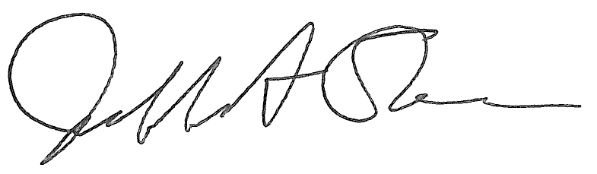

Jeffrey A. Stein

Secretary, Board of Trustees

c. Members of the Board of Trustees  
 President Killeen  
 Mr. McKeever  
 University Officers  
 Members of the Press

**Meeting of the University Healthcare System Committee**

**of the Board of Trustees of the University of Illinois**

University of Illinois Chicago

Isadore and Sadie Dorin Forum, Rooms D, E, and F

725 West Roosevelt Road, Chicago, Illinois

The University Healthcare System Committee Meeting will be webcast live at the following address:

https://www.uis.edu/uislive

Please be advised that the times for various parts of the meeting are estimates and that the order of business may be adjusted as the meeting progresses.

**Wednesday, November 15, 2023**

12:30 p.m. **Meeting of the Committee Convenes**

* Roll Call
* Opening Remarks by the Chair of the Committee
* *Action Item*- Approval of Minutes of Meeting of September 20, 2023
* Opening Remarks by Dr. Robert Barish, vice chancellor for health affairs, Chicago

12:35 p.m. **Review Recommended Board Items for November 16, 2023, Board Meeting**

* Approve Membership and Participation in West Side United, Not-for-Profit, and Appoint Designated Representative, Chicago

12:45 p.m. **Reports**

* + Hospital and Clinics CEO Report, including quality data
  + UI Health Compliance Report
  + Graduate Medical Education Report

1:00 p.m. **Old Business**

**New Business**

* + Next Meeting- January 17, 2024, 12:30 p.m., Isadore and Sadie Dorin Forum, Rooms D, E, and F, 725 West Roosevelt Road, Chicago

1:05 p.m. **Executive Session**

1:20 p.m. **Meeting of the Committee Reconvenes**

* + *Action Item*- Disclose Certain Minutes of Executive Session Pursuant to the Open Meetings Act

1:25 p.m. **Meeting of the Committee Adjourns When Business is Completed**

**Written Reports**

* + Hospital Dashboard